

**Arduino-Based Smart Gas Leakage and Fire Detector System with Gas Booking System**

**A.D.C.M Dissanayaka**

**ITBNM-2110-0013**

**Faculty of Information Technology**

**Horizon Campus**

**Supervisor**

**Ms. Naduni Jayathilake**

**November-2024**

**This project proposal is submitted in partial fulfilment of the requirement of the Degree of Bachelor of Information Technology (Hons) in Network and Mobile Computing of the Horizon Campus.**

**DECLARATION**

I declare that this is my own work and this thesis/dissertation does not incorporate without acknowledgement any material previously submitted for a degree or diploma in any other University or Institute of higher learning and to the best of my knowledge and belief it does not contain any material previously published or written by another person except where the acknowledgement is made in the text. I retain the right to use this content in whole or part in future works (such as articles or books).

Signature: ___________________ Date: _________________

The supervisor/s should certify the thesis/dissertation with the following declaration.

The above candidate has carried out research-based or product-based project for the thesis/dissertation under my supervision. I confirm that the declaration made above by the student is true and correct.

Name of the supervisor: ___________________________________

Signature of the supervisor: ______________________ Date: ________________

**ABSTRACT**

Detection and measurement of combustible gases have become indispensable in many fields. Flammable gas leaks can reach large areas, affect entire neighborhoods or even cities, and have devastating environmental impacts. This paper presents the design of an industrial monitoring system using the Internet of Things. This gas sensor captures information about combustible gas leaks and posts the data to a cloud. The gas sensor can detect combustible gas leaks in many atmospheric conditions. All components are controlled by an Arduino acting as the central processing unit of the setup. When a combustible gas leak is detected, it immediately raises an alarm. The capability of this gas detection system is not only to continuously monitor the surrounding environment, but also to prevent gas leaks, reducing the chances of fires and damage. The Internet of Things (IoT) is an increasingly growing network of various sensors and interconnected devices using the Internet. The usage of IoT devices has become so extensive that IoT-based remote monitoring and controlling of industrial equipment, especially for industrial automation, is conducted on a real-time basis. Traditional gas leak detectors are accurate but fail at effectively warning people in case of a leak. To contribute toward this challenge, an IoT-based gas leak detector was developed with smart alarm capability. Our device will make use of data analysis from sensor readings to predict hazardous conditions in advance and will send timely alerts to surrounding authorities and people for necessary actions. Hence, it provides manufacturers with the capability to automate and, hence, optimize their operational efficiency. This project aims to introduce a design for an industrial monitoring system based on IoT networks. This project focuses on the development of an Arduino-based system for detecting gas leakage and fire hazards. The system automatically sends an alert to the users and connects to a separate web application, which notifies relevant services, such as fire departments or gas supply companies. The web application enables one to reorder when the gas levels are low, and also allows for gas reservation, therefore enhancing safety and convenience for homes and businesses. This functional system will work by warning early in case of accidents and maintaining the continuity of the gas supply.

**ACKNOWLEDGEMENT**

I would like to extend my heartfelt gratitude to Horizon Campus for providing the opportunity to undertake this project. I am deeply thankful to my project supervisor, Ms. Naduni Jayathilake, for their guidance and support throughout the development process.

Additionally, I appreciate the assistance and resources provided by My parents and friends. Lastly, I am grateful for the understanding and encouragement from my family and friends during the course of this project.

# **CHAPTER 1 – INTRODUCTION**

## **Background of the study**

The consequences of gas leaks can include major accidents, explosions, fires, and health risks from the inhalation of toxic gases. Traditional gas detection methods require manual inspection and are usually reactive rather than proactive. An Arduino-based smart gas leak detector system is designed to provide an automated and efficient solution for early detection and response to gas leaks in order to increase safety and minimize possible damage. Gas leakage is one of the most serious environmental, commercial, and residential problems that threatens human health, safety, and the environment. Traditional gas detection methods often lack time-tracking capabilities, and failure to provide timely information leads to accidents and damages. In this regard, IoT technology has been proven to offer a solution of high reliability for continuous monitoring and remote management of gas detection systems. [1] The paper attempts to present a gas leakage detection system based on the IoT that could improve safety, reducing the risk of gas leakage. The proposed system integrated gas sensors, microcontrollers, communication modules, and cloud computing infrastructure in the implementation of real-time monitoring, data analysis, and remote monitoring of the leaks. There are various gas detectors positioned at points in designated areas showing the presence of hazardous gases. Data are collected directly from the central processing unit for analysis. The system provides fast rescue and intervention by sending instant notifications via the web site in view of a gas leakage. The key features of the proposed system are scalability, flexibility, and interoperability, allowing integration with existing infrastructure and integration of various protocols. Moreover, the cloud-based platform simplifies data storage, analysis, and visualization for partners to gain insight into gas leaks, processes, and possible consequences. This section shows the background and importance of the project. It presents the hazards related to gas leakage and the shortcomings of traditional methods of detection. The aim is to lay the foundation for the necessity of an automated gas detection system. [2]

## **Problem Statement**

Gas leaks can lead to major accidents, including explosions, fires, and health risks from inhaling toxic gases. Traditional gas detection methods require manual inspection and are usually reactive rather than proactive. An automated gas leak detection system using Arduino technology aims to provide an effective solution for the timely detection and response to gas leaks, ensuring increased safety and reducing possible damage. Also, the system has been connected to a stand-alone web application that will alert the relevant services, such as fire departments and gas supply firms, in the event of fire detection. [3] The web application will allow re-ordering when gas levels get low and notify the fire company with location, the web application will also inform the gas supply company when refilling is needed, it will monitor domestic gas cylinder levels as well. The section shows the background of the project and its importance. The discussion centers around the hazards associated with gas leaks, pointing out the shortcomings of traditional detection methods, such as long response times and increased risks in current manual testing procedures. Moreover, the necessity of immediate detection of fire events and location-specific warning systems is underlined with the utmost importance for an uninterrupted gas supply without sudden activations. [4] There has to be an automated system that can detect gas leakage quickly and accurately, warn the residents, alert the relevant bodies in case of fire, and control the gas supply efficiently. The enhanced system reduces the potential risks, shortens response times, and provides a reliable and comprehensive security system for homes, offices, and industries. The importance of this initiative is underscored by its capacity to offer a consistent, automated mechanism for detecting gas leaks, preventing fire hazards, and managing gas supply, thereby reducing the chances of explosions, fires, and health risks. This section covers the rationale of the project and its importance by pointing out the benefits and what impact the proposed system could have on safety, accident prevention, and resource utilization.

## **1.3 Motivation and significant of the project.**

## **1.3.1. Motivation**

The motivation behind this project is to improve safety and prevent accidents due to gas leakage. The importance of the project is that it will provide a reliable, automated solution for gas leak detection, reducing the risk of explosions, fire, and health hazards. This section explains the driving force behind the project and its importance. The basis is to focus on potential benefits and impact that the system could give to improve the safety of an accident prevention point. This proposed system's motivating principle is, in general, accident avoidance and improving safety through automated gas leakage and fire hazard alerts. Thus, the significance of the entire work towards saving properties and lives while booking a gas automatically keeps it convenient and ready with no manual checking.

## **1.3.2. Significant**

The significance of this system lies in its **protective role** for both **people and property**. Here’s how it accomplishes that:

* Automated Detection: It alerts users immediately when a gas leak or fire is detected, giving them time to act and prevent accidents.
* Gas Booking System: When the gas level in the cylinder is low, the website and display connected to the system informs the by of the gas level, thus inform the need for refilling and contacting suppliers. This helps to reduce and avoid the hassle of manually checking gas levels.
* Also, this system works to pull the LPG gas coming out of any leakage from the relevant place and release it to the external environment. An exhaust fan system has been installed for that purpose.
* Also, if the system detects any LPG gas leakage or any fire situation, the system will turn off the main gas supply.

## **1.4. Aims and objectives of the project**

## **1.4.1 Aims of the project**

The objective of this research is to develop and evaluate an Arduino-based automation system that increases safety in residential, commercial, and industrial settings by accurately detecting gas leaks, providing real-time fire alerts to fire companies with location data, and managing gas. Provision through an true a web site gas booking process. Research seeks to integrate these functions into an integrated system, ensuring reliability, efficiency and timely response to potential hazards.

## **1.4.2 Objectives**

1. Build a gas leakage and fire detector system using Arduino, integrating sensors like MQ2 and MQ5 and flame sensor for detecting LPG and methane gas and fires.
2. Implement autonomous navigation and control algorithms to detect gas leaks and fires, display real-time gas levels on an LCD, and operate an exhaust fan system to expel leaked gases.
3. Develop a notification system to alert users via a website, phone calls, and text messages about gas leaks and refill requirements for gas cylinders.

## **1.4.3 Limitations of the project**

* **Sensor Sensitivity and Accuracy:** Gas and fire sensors (such as MQ2, MQ5, and fire sensors) may have detection limits for certain gas types or low concentrations. They can also be affected by environmental factors such as humidity and temperature, which can affect their accuracy And, in some cases, sensors may trigger false alarms due to factors unrelated to gas leaks or fire, such as dust, cooking smoke, or temperature fluctuations.
* **Response Time of Alerts and Bookings:** While the system is designed to send alerts immediately, there may be delays in notifications or automatic gas reservations due to internet or mobile network connectivity issues. This delay can affect the promptness of the response, especially in emergency situations where urgent action is required.
* **Power Supply Dependency:** The system relies on an uninterrupted power source to function properly. If there is a power outage and there is no backup battery, the system will shut down, and the area can be left unattended during this time. Operating the system solely on batteries can reduce its operating time and require frequent recharging or replacement, especially if it includes high-power components such as the exhaust fan.
* **Limited detection range:** The system's sensors typically only work within a certain radius. If the gas leak or fire source is located beyond the sensor range, the system will not immediately detect it. For larger spaces or buildings, additional sensors may be required to cover all areas, increasing the complexity and cost of the project.
* **Maintenance and Calibration**: Sensors require periodic calibration to maintain their accuracy. Over time, their sensitivity may decrease, leading to reduced detection efficiency. Regular maintenance is essential and can add to the maintenance costs of the system. A build-up of dust or dirt on the sensors can interfere with their performance, requiring regular cleaning.
* **Environmental interference:** Environmental conditions such as strong winds, humidity, or high temperatures can affect the performance of sensors and exhaust fans. For example, high humidity can reduce the sensitivity of gas sensors, and high heat can damage sensitive electronic components.
* **Privacy and Security Risks:** Since the system transmits data over the Internet or mobile phone networks, there is a risk of unauthorized access. A secure setup is required to protect the data and prevent tampering with alarms or gas separation functions.
* **High initial setup costs:** Including multiple sensors, a SIM module, a Wi-Fi module, an exhaust fan, and other components can increase the initial cost. For some users, cost may be a barrier to adoption, especially if additional equipment is required for larger spaces.

# **CHAPTER 2 - LITERATURE REVIEW**

## **2.1 Introduction**

The lack of an effective mechanism to monitor and control gas leakages in households has emerged as a significant concern. Much attention has been directed toward understanding the impacts of reducing the rate of gas leakages, prompting active research in this area. This chapter evaluates several efforts that have been made to address this pressing issue. Numerous researchers have proposed various methods aimed at eradicating the problem identified earlier, and a selection of these methods will be critically evaluated. After reviewing the contributions of different researchers, a vibrant and innovative possible solution will be devised, incorporating some of the successful concepts previously employed.

Liquefied Petroleum Gas (LPG) was to begin with created in 1910 by Walter Snelling (Didpaye1, 2015) and is classified as a dangerous a material due to its profoundly combustible properties and dangerous potential. when stored under pressure. Before the advent of electronic household gas detectors in the 1980s and 1990s, the presence of gas was detected using chemically infused paper that would change color upon exposure to the gas (Didpaye1, 2015). Since that time, a range of technologies and devices have been developed to detect, monitor, and alert users to the leakage of various gases. Therefore, the need for an efficient system to monitor and control LPG leakages, particularly for domestic use, is critical. [5]

Regardless of the safety standards implemented during the use of gas, which are designed to prevent leakages, the inherent risk of a gas leak remains (Didpaye1, 2015). Human error is an unavoidable factor in this equation. LPG gas is both odorless and colorless, making it exceedingly difficult to detect a gas leakage without assistance. Although an odorant is typically added to LPG to aid in its detection, this measure is insufficient, as it requires a person to be physically present to notice the smell. By the time the gas has accumulated to a detectable concentration, it may have already reached a dangerous level Hence, depending exclusively on the human sense of scent to decide the nearness of a gas spill postures critical dangers. [1]

The potential hazards associated with gas leakage have long been a source of concern, leading to the development of various gas leakage detectors aimed at addressing this issue. The detectors that have been created are largely based on existing gas detection technologies, and their effectiveness is continually being assessed and improved. As the need for enhanced safety measures grows, further innovation in gas detection technology is essential to ensure the safety and well-being of households everywhere.

## **2.2 LPG Detection in General**

Gas leak detectors are designed to detect liquefied petroleum gas (LPG) leaks in the area where they are installed and put into service. This is a significant safety issue because LPG is highly flammable and can pose a serious risk to property and life safety if not detected quickly. Various methods and technologies have been explored in the literature for detecting LPG gas, including the use of sensors like MQ-5 or MQ-2, as well as more traditional methods such as electrical cables, which serve as conductive pathways for detecting gas presence.

Various sessors are used. These sensors are specifically calibrated to detect the presence of LPG in the air, and they operate by measuring the concentration of gas particles in the environment. When a gas spillage happens, the sensors react by creating a voltage yield that relates with the concentration of the gas recognized. This output can then be processed by a microcontroller or similar device, which can trigger alarms or notifications to alert individuals in the vicinity of a potential hazard. [6]

In addition to these sensors, advancements in technology have also led to the development of more sophisticated gas detection systems that can integrate with smart home technologies, offering real-time monitoring and alerts through mobile applications. This enhancement not only increases safety but also provides users with peace of mind, knowing that they are protected from the dangers associated with gas leaks. Overall, the development and deployment of effective gas leakage detectors play a crucial role in enhancing safety protocols in both residential and commercial settings. [7]

## **2.3 LPG Neutralization in General**

In this particular scenario, one effective approach to enhancing safety and minimizing potential hazards involves the strategic reduction of the concentration level of Liquefied Petroleum Gas (LPG) in the area where it is being utilized. This can be achieved by implementing a system that actively emits the gas outside of the enclosed space, thereby ensuring that any accumulation of LPG is effectively mitigated. One of the most efficient methods for achieving this is through the use of exhaust fans, which are designed to facilitate the removal of air contaminants from the environment. [2]

By installing these exhaust fans in strategic locations, it becomes possible to create a continuous flow of air that helps to dilute and disperse the LPG, preventing it from reaching dangerous concentrations that could pose significant risks to health and safety. This proactive measure not only enhances the overall ventilation of the area but also plays a crucial role in ensuring that any escaped gas is swiftly directed outside, away from individuals and sensitive equipment.

Additionally, regular maintenance and monitoring of the exhaust system are essential to ensure its effectiveness. By consistently checking for any blockages or malfunctions, as well as ensuring that the fans are operating at optimal capacity, we can further minimize the risk associated with LPG usage. Overall, the implementation of this strategy is vital in maintaining a safe working environment where LPG is present.

## **2.4 Notification in General**

Producing an early warning signal under less severe conditions is a crucial feature that enhances safety during the leakage of liquefied petroleum gas (LPG). This advanced system activates a high-pitched alarm, which effectively alerts individuals in the vicinity of the potential danger. In addition to this auditory warning, the system is designed to send an instant SMS message via an Android application directly to the consumer’s mobile device. This dual notification process ensures that the consumer is promptly informed about the situation, allowing them to take appropriate action to mitigate any risks associated with LPG leakage.

In addition, if the LPG concentration is above normal safety, the system immediately gives an audible warning, which increases the importance of the situation. At this point, an alert message is also dispatched to an authorized person through the GSM network, ensuring that help can be mobilized quickly. This two-tiered notification system is particularly beneficial in preventing accidents and ensuring the safety of both individuals and property. [4]

In addition to these measures, we are planning to implement a phone call feature. If the consumer does not respond to the SMS notification within a specified timeframe, the system will automatically initiate a phone call to the consumer. This ensures that even if the SMS is overlooked or not seen, there is still an opportunity for the individual to receive the critical information and respond accordingly. This comprehensive approach to safety and communication aims to minimize risks and enhance the overall effectiveness of the LPG leakage monitoring system. [3]

## **2.5 Smart Technology in General**

Smart innovation is around pressing huge execution changes out of everything. Smart innovation has developed quickly in bolster for subordinate individuals as well as a instrument to upgrade productivity and compelling observing of gas spillages in households. these days, savvy domestic basically addresses the integration of data innovation into families. Smart homes have become a very active and firmly researched topic. The area is fast developing and attracting synergies of several areas of sciences, for improving human’s quality of living. "What makes a home smart are the interactive technologies that it contains” which could help to realize helpful home. [2]

According to Nowak (2011:270) nowadays, smart home mainly addresses the integration of information technology into households. Interconnections between devices and advanced control of household appliances are increasing the comfort levels of inhabitants as well as a key tool to enhance the reduction in the rate of gas leakages as it was pointed out by Jakkula (2006). [2]

Smart technology has enhanced control of inside-house appliances remotely and without any human intervention. Smart technology has grown rapidly in support for dependent people as well as a tool to enhance efficiency and effective monitoring of gas leakages in households.

# **2.6 Overview of Existing Systems**

## **2.6.1** **Microcontroller-Based Cooking Gas Leakage Detector**

The use of a microcontroller enables the development of a highly accurate and fast response detection system. The detector incorporates an MQ-6 sensor (with a gas detection range of 300-10000ppm) as the LPG gas sensor, a PIC16F690 microcontroller as the control unit, an LCD for displaying gas concentration, a buzzer as an alarm, and several LEDs to indicate the gas leakage status. The microcontroller senses the presence of a gas when the voltage signal from the MQ-6 sensor goes beyond a certain level and gives an audiovisual alarm. The microcontroller is programmed using PIC assembly language and all the peripherals are connected to it through its pins. System shows the affection on display. LPG gas is released and the sensor voltage signal is monitored using a digital multimeter. Below 2.0V, the green LED remains on, and when the voltage is equal to or greater than 2.0V, the microcontroller will flash the red LED and give an alarm to indicate that there is fuel. There is a button to control the alarm. This sensor has a high tolerance for cleaning the air. When LPG gas is present, the voltage meter increases, and when the voltage meter outputs 2.0V, the voltage meter is characterized by the gas concentration of 300ppm, so the impedance is 2.0V. Therefore, the single-chip oil leak detector based on PIC16F690 single-chip and MQ-6 sensor can detect gas leakage of more than 300ppm and provide audiovisual signals. [1]

The system can detect gas leaks and warn the owner with an audible alarm. However, in cases where the owner is not present, the system can detect gas leaks and alert owners with an alarm.

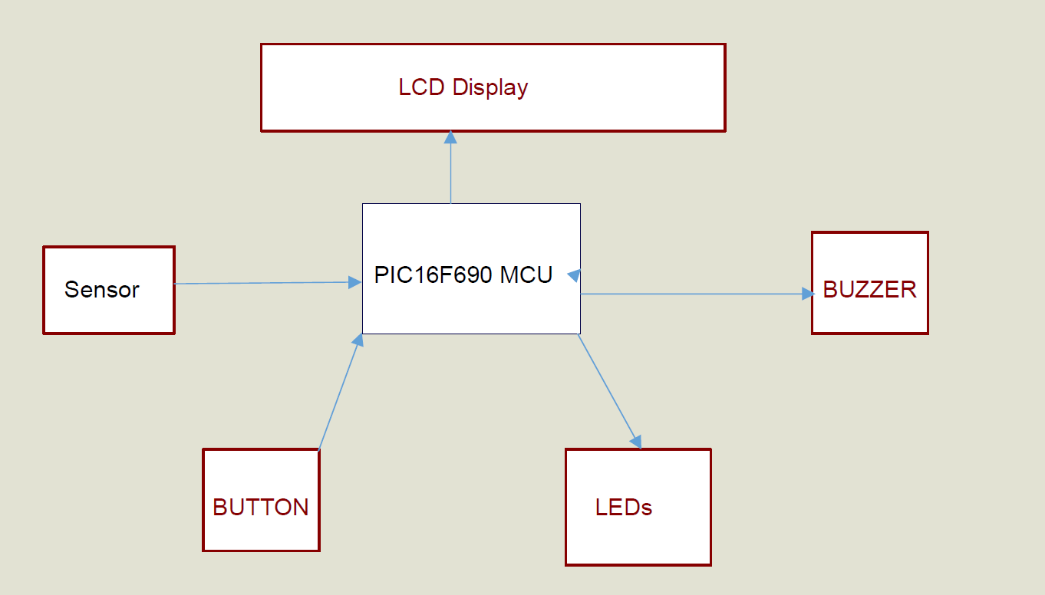Figure 1:MICROCONTROLLER-BASED COOKING GAS LEAKAGE

## **2.6.2** **Arduino-Based LPG Gas Monitoring & Automatic Cylinder Booking with An Alert System**

The main aim of the program is to monitor liquefied petroleum gas (LPG) leaks to prevent major fires and to promote safety measures (usual safe location is a critical issue) and automatic cylinder booking without human intervention. The system detects the leakage of the LPG using a gas sensor and alerts the consumer about the gas leakage by sending an SMS. The system measures the weight of the cylinder by using a weight sensor and displays the corresponding weight in the LPG display. This plan uses GSM modems to alert people to gas leaks through SMS messages and the status of automatic gas cylinder reservations. When the system detects that the concentration of liquefied petroleum gas in the air has reached the specified level, it notifies the user by sending a text message to the customer's mobile phone. Consumers send SMS to a registered mobile phone and alert the people at home by activating the alarm which includes a Buzzer simultaneously and also displaying the same message on LCD to take the necessary action. [8]

However, the system could not take necessary actions to stop the gas from leaking, and also the owner could not measure the rate at which the gas was leaking. The system cannot tell where the leak is coming from, for example whether it is coming from the outlet valve or the tank.

Figure 2: AUTOMATIC CYLINDER BOOKING WITH AN ALERT SYSTEM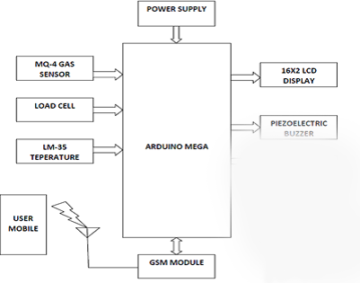

## **2.6.3** **LPG Leakage Detection and Prevention System**

Gas leak detection involves identifying hazardous gases in the environment using sensors to prevent dangerous repercussions. Liquefied Petroleum Gas (LPG) is a flammable hydrocarbon composed of propane, butane, isobutane, and their mixtures, widely used in industrial applications like space and process heating, powering industrial ovens, kilns, furnaces, and forklifts, as well as in domestic settings for cooking, lighting, and refrigeration. Despite its high calorific value and environmentally friendly properties, LPG leakage is extremely dangerous, increasing the risk of fire explosions, financial loss, and human casualties, often due to substandard cylinders, old valves, worn-out regulators, and lack of awareness. To address this, the proposed system uses a gas sensor to monitor LPG concentration and audibly notify users and neighbors via a buzzer, while also sending a warning message to the user. A stepper motor closes the gas valves, a relay turns off the main power supply, and a 16x2 LCD display provides visual warnings. The sensor data is also accessible via a mobile application for monitoring gas concentration, especially useful in industrial settings. [9]

This work aimed to monitor for liquid petroleum gas (LPG) leakage to avoid fire accidents providing safety features where security is an important issue. The system detects the leakage of the LPG using a gas sensor and temperature using a temperature sensor and alerts the consumer about the gas leakage by triggering a buzzer. The proposed system uses the AT89C51Microcontroller and a simple alarm system to alert the person about the gas leakage via an alarm. When the system detects the LPG concentration in the air exceeds a certain level then it immediately alerts the consumer by activating the alarm which includes the LED, Buzzer simultaneously and displays the message on the LCD to take the necessary action and take any precautionary steps to decrease the gas concentration in the air Here exhaust fans are used to remove LPG gas from the air.

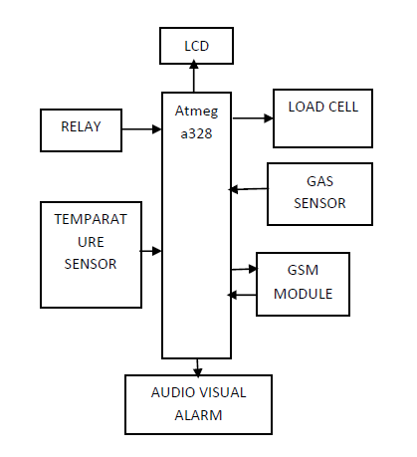Figure 3:LPG Leakage Detection and Prevention System

## **2.6.4** **LPG Leakage Detection control System**

V. Abishek, has developed a system for the detection of gas leakage incorporated with the tripping mechanism of the main power supply to avoid any explosion due to it. The developed system used a transmitter and receiver module interfaced with the microcontroller programming. The developed system has been implemented and tested to conclude that the working of the system depends upon the concentration of gas present in the system. When the gas concentration reaches the threshold, the main circuit is closed and the alarm sounds However, When the gas concentration reaches the threshold, the main circuit is closed and the alarm sounds.

The objective of this project is to detect gas leakage in LPG based small-scale factories, or home appliances, and automatically close the gas supply knob using a stepper motor upon detection, while alerting the user with an alarm and an LCD display. Gas sensors, which are crucial in safety and health applications, have high sensitivity, compact size, and reduced power consumption, making them suitable for various applications including domestic/commercial alarms, automotive gas leakage detectors, air quality control, and pollution monitoring. Designing a reliable gas detection system requires careful consideration of factors such as environmental temperature, sensor life, and constant monitoring of sensor elements to avoid false alarms. The project utilizes a microcontroller to replace numerous external components while adding functionalities, ensuring cost-effectiveness and reliability. The hardware and microprocessor firmware are optimized to create a smart LPG gas alarm system, aiming to raise alarms before any fatal incidents occur. [10]

Figure 4:LPG Leakage Detection control System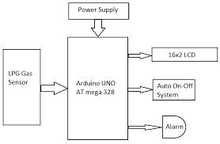

## **2.6.5 Gas leakage detection system**

A gas detector, which is frequently a component of a safety system, is a device that detects the presence of gases in an area. This kind of apparatus can interface with a control system to enable the automatic shutdown of a process and is used to detect gas leaks and other pollution. Operators in the vicinity of the leak can be given the opportunity to evacuate by having a gas detector alert them. Oxygen depletion and poisonous, flammable, and combustible gases can all be found with gas detectors. This kind of equipment is frequently used in industry to monitor production processes and cutting-edge technology like photovoltaics. It can be found in places like oil rigs. They could be applied to fighting fires. [11]

Gas leak detection is the process of identifying potentially hazardous gas leaks by sensors. These sensors usually employ an audible alarm to alert people when a dangerous gas has been detected. Exposure to toxic gases can also occur in operations such as painting, fumigation, fuel filling, construction, excavation of contaminated soils, landfill operations, entering confined spaces, etc.

Common sensors include combustible gas sensors, photoionization detectors, infrared point sensors, ultrasonic sensors, electrochemical gas sensors, and semiconductor sensors. More recently, infrared imaging sensors have come into use.

Selvapriya C. A microcontroller model for indoor air pollution has been developed using sensors. The development tool is programmed to interact with and test the microcontroller. Test results generate audio and visual alerts for users and send text messages (SMS) to users. This Sensor is most accurate the sensor also detects isobutane, propane and smoke.

If the business owner forgets to close the valve properly, the valve can be closed without human intervention. The system also can't tell where the gas is coming from, whether it's coming from the exhaust valve or somewhere else.

Figure 5:Gas leakage detection system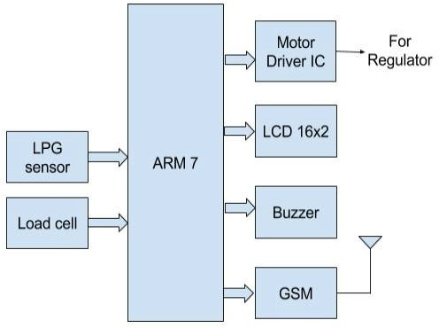

## **2.6.6** **Detection System, Using GSM**

Ashish Shrivastava another one who make gas detector. The system used a highly sensitive sensor to sense the concentration of gas such as propane (C3H8) and Butane (C4H10). GSM (Global System for Mobile Communication) module was incorporated, which sends a warning SMS to the user. The design was tested using a small amount of LPG near the sensor and monitoring the buzzer and worked satisfactorily. [2]

However, the system was unable to stop gas leakage or provide any action to neutralize the gas. The owner could not be able to monitor the situation remotely if he/she is not present in the household thus the system only notifies the owner that there is a leakage but cannot tell where the leakage is coming from.

**See the Diagram below**

Figure 6:Detection System, Using GSM

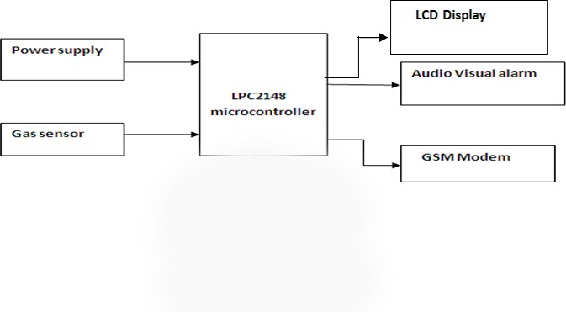

## **2.6.7 GSM-based Gas Leakage Detection System**

S. Siva Jothi Kavitha proposed a wireless home transmitter with three main modules: oil leak and liquid level detection and transmission module (GSM/GPRS MODEM) and receiver module (GSM mobile). Gas detectors and transmissions detect changes in LPG and natural gas and activate audible and visual alarms when certain threshold values are exceeded. Continuous monitoring of LPG level to see cylinder weight upon delivery and throughout the process

Usage. The auto-renewal system is alerted when the cylinder is going to be emptied and auto-booking is done with the gas station also giving the information to the consumer. [5]

However, the system could not provide a solution to stop the gas leakage therefore if the owner was not present at the spot the risk of explosion was very high since the leakage could not be stopped. If there is a leakage there is no way to neutralize the gas.

**Below diagram show**

Figure 7:GSM-based Gas Leakage Detection System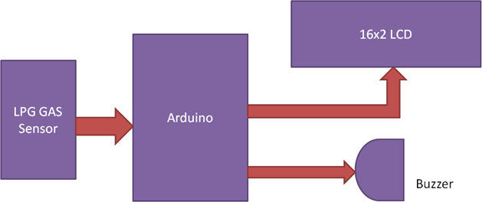

The system could not take any necessary action to stop the gas leakage or notify the owner remotely, which poses a significant risk to safety. Another major problem is that it could not neutralize the gas that has leaked in the room, leaving the area dangerously hazardous. As a result, the chances of a gas explosion are very high, creating an urgent need for immediate intervention. This lack of functionality not only endangers the property but also puts the lives of those nearby at serious risk. [2]

## **Conclusion**

The literature on smart gas leak detection systems highlights their critical role in enhancing safety and operational efficiency across various environments, from residential spaces to industrial facilities. Traditional gas leak detection methods, while foundational, often fall short in terms of sensitivity, reliability, and real-time response. Smart gas leak detectors, equipped with advanced technologies such as IoT, sophisticated sensors, machine learning, and data analytics, offer significant improvements over their predecessors.

## **Key findings from the literature include:**

* **Enhanced Accuracy and Sensitivity:** Modern sensors used in smart detectors are capable of detecting lower concentrations of gases with greater precision, reducing the risk of false negatives.
* **Reduced False Alarms:** By integrating machine learning and AI, smart detectors can better distinguish between actual gas leaks and non-hazardous events, thereby minimizing false alarms and ensuring that resources are not wasted on unnecessary responses.
* **Real-Time Monitoring and Alerts:** IoT-enabled detectors provide continuous monitoring and can send instant alerts to users, allowing for prompt action even when the user is not physically present. This capability is particularly valuable in mitigating risks in industrial settings where rapid response is crucial.
* **Predictive Maintenance:** The ability to analyze data over time and predict potential issues before they become critical helps in maintaining safety and efficiency. Predictive maintenance significantly reduces both downtime and repair costs, ultimately leading to increased efficiency within operations. By utilizing smart detectors, businesses can proactively identify potential issues before they escalate into major problems. This approach not only minimizes unplanned outages but also ensures a more reliable and cost-effective solution in the long run. As a result, organizations can allocate resources more effectively and focus on their core activities, enhancing overall productivity and profitability.
* **User Convenience and Peace of Mind:** Remote monitoring and control features enhance user convenience and provide peace of mind, knowing that the system is actively safeguarding against gas leaks.

Overall, the seamless integration of cutting-edge technologies in modern gas leak detection systems represents a transformative and innovative approach to enhancing safety and efficiency in various industrial applications and environments. The ongoing advancements in this field are likely to yield even more sophisticated and reliable solutions, further reducing the risks associated with gas leaks.

The literature suggests that the adoption of smart gas leak detection systems is not only a technological upgrade but a necessary evolution in ensuring the safety of environments where gas leaks can occur. Future research and development should continue to focus on improving sensor technologies, enhancing machine learning algorithms, and expanding IoT capabilities to provide even more robust and user-friendly solutions. As these systems become more widespread and affordable, their impact on safety and operational efficiency will only increase, making them an essential component of modern safety protocols. And also introducing our latest feature: Gas Level Detection! With this cutting-edge addition, consumers can now easily monitor gas levels directly from their mobile app. This feature utilizes advanced sensor integration to provide real-time gas level readings, ensuring safety and convenience. Whether you're at home or on the go, stay informed about your gas usage and receive instant alerts if levels reach critical thresholds. Simplify your life and enhance your safety with our new Gas Level Detection feature.

# **Chapter 3 - Analysis**

## **3.1 Introduction**

The analysis section highlights some specific requirements for the implementation of the gas reservation system using Arduino-based Smart Gas Leakage and Fire Detector System. It also identifies the critical safety risks caused by gas leaks and fire hazards, pointing out the shortcomings of traditional systems in terms of delayed response and manual monitoring. The proposed solution integrates IoT-enabled sensors-MQ2, MQ5, and fire sensors-with communication modules for real-time alerts and automated gas reservations.

The system will provide benefits like automation in hazard detection, timely response to users and authorities by notifications, and user convenience by displaying data on LCDs and mobile applications. This analysis focuses on the objectives that define functional and non-functional requirements, compare the system with existing solutions, and outline the hardware and software specifications required to ensure reliability, efficiency, and scalability. This section lays a good foundation for designing a proactive and comprehensive security system.

## **3.2 Feasibility Study**

Feasibility studies can be done for many purposes and sometimes are done in IT in order to in general, feasibility is related to how new hardware and software setups can be looked at. Aligning with this helps become aware of problems that could arise in implementation process of the project.

The five-point model called TELOS this includes the following components,

* Technical Feasibility
* Operational Feasibility
* Financial Feasibility
* Economic Feasibility
* Legal Feasibility

## **3.2.1 Technical Feasibility**

The technical feasibility of the Arduino-Based Smart Gas Leakage and Fire Detector System with a Gas Booking System examines the practicality of implementing the project using available technologies, components, and methodologies. It evaluates whether the proposed system can be successfully developed and deployed within the project's scope.

* Hardware Components - Uno Board, Node MCU(ESP8266), SIM900A GSM Module, Servo Motor, MQ2 Gas Sensor, MQ5 Gas sensor, Buzzer, Relay Module, Flame Sensor, Jumper Wires, Bread Board, DHT11 Sensor, Load Cell Sensor, LCD Display, Exhaust Fan
* Language - Html, CSS, Java Script, C++
* Software - Arduino IDE
* Cloud – Firebase
* Tool - Uno boards wire

## **3.2.2 Operational Feasibility**

The Arduino-based Smart Gas Leakage and Fire Detector System with a gas-booking system is very practical and efficient in its operational feasibility. The system is designed in such a way that it assures the users of enhanced safety and convenience through automation of crucial tasks involving gas leakage detection, fire alarm, and gas booking. The user experience is also pretty interactive, with real-time notifications via SMS, mobile apps, and visual alerts on an LCD display. Mechanizing certain tasks, such as the monitoring of gas levels, automatically alerts concerned authorities or suppliers; this greatly eliminates the possibility of human error.

It's a system, adaptable for residential, commercial, and industrial use, thus accessible to a wide community of users. The system easily integrates with the security protocols already in place, making it easier to bring in greater operational efficiency with much less change to the existing infrastructure.

Its modular design makes it easy to maintain and scale, ensuring reliability over time. It handles potential challenges of false alarms or connectivity issues through careful sensor calibration and strategic placement, including offline fallback options such as buzzers and LEDs. The system becomes highly reliable with the use of backup power continuity, remote monitoring, and, most importantly, IoT technology. The users get increased safety and peace of mind since potentially hazardous situations are picked up early, and efficient management between gas supply and demand is assured. With this, one can strengthen operational feasibility fully in real-world settings.

## **3.2.3 Financial Feasibility**

The financial feasibility of the Arduino-Based Smart Gas Leakage and Fire Detector System with a Gas Booking System evaluates the cost-effectiveness and economic viability of developing and implementing the project. This analysis ensures that the project's expenses are justified by its benefits and potential for widespread adoption. Financial feasibility is to study the project, how much start-up capital is needed for devices and other sensor modules. In this project the capital expenses are as follows, costs are sensors and Arduino board.

|  |  |  |  |
| --- | --- | --- | --- |
| **Item** | **Price (Rs)** | **Total (Rs)** | |
| **Rs** | **Se.** |
| Arduino Uno Board | 2700.00 | 2700 | 00 |
| ESP8266 WI-FI Board | 850.00 | 850 | 00 |
| Bread Board | 380.00 | 380 | 00 |
| GSM Module | 2750.00 | 2750 | 00 |
| 2 Relay Module | 480.00 x 2 | 960 | 00 |
| Buzzers | 180.00 | 180 | 00 |
| 2 Flame sensors | 270.00 x 2 | 540 | 00 |
| Servo Motors | 650.00 | 650 | 00 |
| 3 MQ5 Sensor | 280.00 x 3 | 840 | 00 |
| 3 Lithium Ion Battery | 550.00 x 3 | 1650 | 00 |
| Switch | 180 | 180 | 00 |
| Jumper wires | 750.00 | 750 | 00 |
| DHT 11 Sensor | 370.00 | 370 | 00 |
| Load Cell Sensor | 680.00 | 680 | 00 |
| LCD Display | 650.00 | 650 | 00 |
| Battery Pack | 380.00 | 380 | 00 |
| 4 Exhaust Fan | 550.00 x 4 | 2200 | 00 |
| 2 Emergency Light | 550.00 x 2 | 1100 | 00 |
| Gas Regulator | 1200.00 | 1200 | 00 |
| Power Adapter (5V-2A) | 900.00 | 900 | 00 |
| Other | 8000.00 | 8000 | 00 |
| **Total** | | **27910.00** | |

Table 1 - Financial Feasibility

## **3.2.4 Economic Feasibility**

The Arduino-Based Smart Gas Leakage and Fire Detector with a Gas Booking System is economical. The initial cost in development can be reduced if affordable and available components, such as Arduino Uno, MQ2 and MQ5 sensors, and SIM modules, are used. This will give better long-term benefits. The system's gas and fire detection capabilities allow for early detection, thus preventing costly accidents and damage to property, as well as possible loss of life. Also, users may experience savings on insurance premiums due to enhanced safety measures. Automation of gas-level monitoring and booking saves time and provides operational continuity, reducing disturbances in residential and commercial settings. The system is very affordable, thus easily applied in every household and business, owing to its low cost; it is also modular and scalable, therefore easily customizable at an affordable price. Further, it supports public welfare through prevention of hazards and reduction in societal costs associated with emergencies, such as healthcare expenses and emergency response efforts. With growing demand for IoT-based safety solutions, the project has strong market potential and is aptly suited for broader commercial deployment. That combination of improved safety and operational efficiency, along with cost savings, means that the project is economically viable, deriving considerable value for users and stakeholders.

Economic feasibility assessment is intended to identify the positive economic benefits that the proposed system will bring to the organization. This project usually includes a cost-benefit analysis. All sensors used in this project are cost-effective. There is no need for a large investment to be involved in the entire process.

The cost of making a one device = Rs.27900.00

Expected amount to sell a one device = Rs.45000.00

Proceeds from the sale of one hundred devices = Rs.4500000.00

Net profit from the sale of one hundred devices = Rs.1710000.00

This cost is approximately for one standard only. Because there can be different constructions in domestic, commercial and industrial environments, the prices can vary according to the way sensors are used for each construction.

## **3.2.5 Legal Feasibility**

The legal feasibility of the Arduino-based Smart Gas Leakage and Fire Detector System with Gas Booking System ensures the project is developed in compliance with all applicable laws, regulations, and standards. The system shall meet the safety standard requirements of ISO and NFPA to ensure reliable performance of the system in the detection of gas leakage and fire hazards. In addition, the electronic components and sensors have to meet the regulatory requirements for accuracy and safe use in hazardous environments.

The system, therefore, has to comply with the data protection regulation in sending out notifications via SMS, calls, and applications on mobile phones something like GDPR or its local equivalent. It has to securely handle user data that is, contact information and location to prevent unauthorized use or misuse. All IoT components, including the SIM and WIFI modules, shall be in compliance with the regulations of telecommunications that operate under licensed frequency bands and within emission standards. This ensures that these systems do not cause interference with other apparatus.

Clear instructions of the system for the users, reliability in all conditions, and warnings of its limitations reduce the possibility of liability claims. The environmental standards like RoHS ensure that the components do not contain hazardous substances and proper practices are followed for their disposal. Intellectual property issues must be addressed by ensuring that no infringement of existing patents occurs and by securing IP rights for any innovative features of the system.

With such requirements satisfied, the project ensures the legality of its operation and significantly decreases any possible regulatory or legal challenges. Addressing these legal aspects further solidifies the credibility of the system and makes it more easily usable in practical applications.

## **3.3 Fact Finding Techniques**

## **3.3.1 Survey Question**

This part of the project involved a survey using Google Forms to collect information on public perceptions and needs in relation to gas safety, fire hazards, and a possible implementation of an automated gas leakage and fire detection system with a gas booking feature. The target group for the survey is a diverse population, chosen at random to include people from different walks of life and demographic backgrounds. This approach gave a clear view of the expectations of the users and the challenges in relation to gas safety and fire prevention.

A structured survey with closed-ended questions multiple-choice and Likert scale queries was conducted to collect quantifiable data. The questions were directed to the level of knowledge of gas leakage risks and fire safety protocols among the participants, attitudes toward automated safety systems, and expectations or concerns about features including automated notifications, gas booking, and fire detection technologies.

Such a list could not be more critical for a project like the Arduino-Based Smart Gas Leakage and Fire Detector with a Gas Booking System. This project has taken into consideration the concerns and feedback that users may have, thereby ensuring that in the long run, there will be an improved yet practical system provided to the end-users. The key characteristics identified through this feedback-driven approach, including real-time alerts and automated gas booking, have intuitive interfaces to make the system useful for the end-user, taking into account potential challenges pointed out during the survey.

Figure 8: Survey Question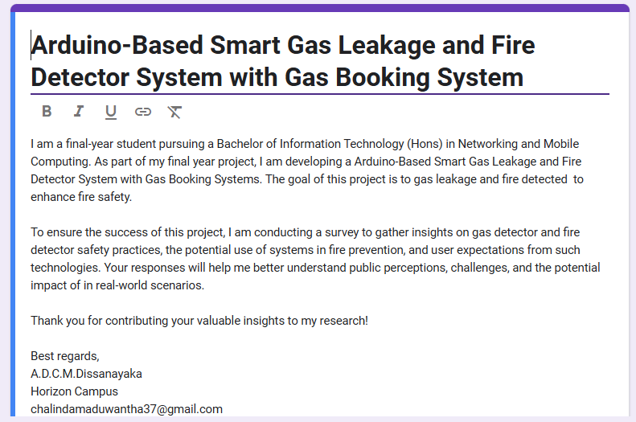

Figure 9 - Question 01,02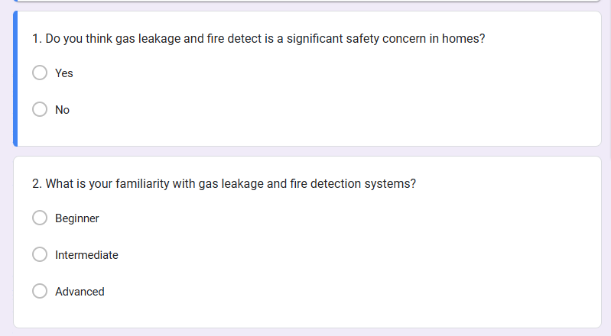

Figure 10 - Question 03,04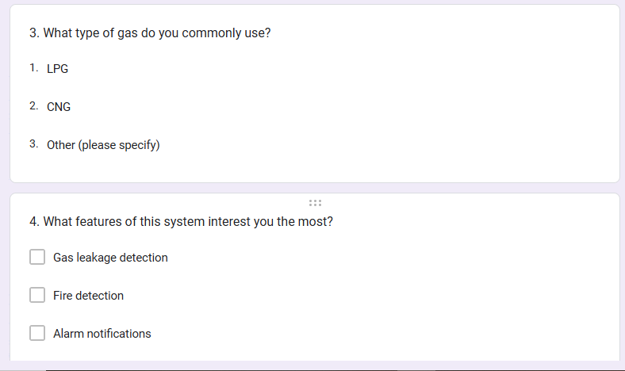

Figure 11- Question 05,06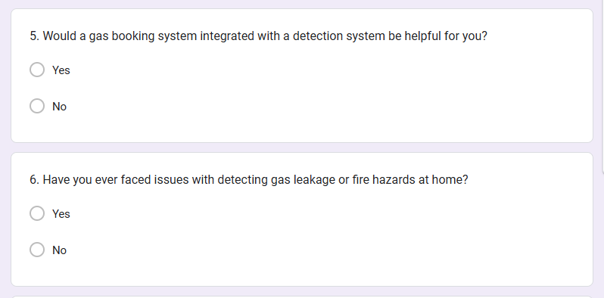

Figure 12- Question 07,08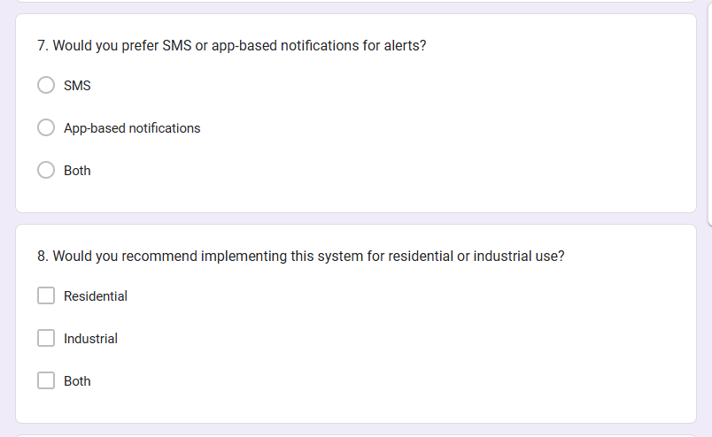

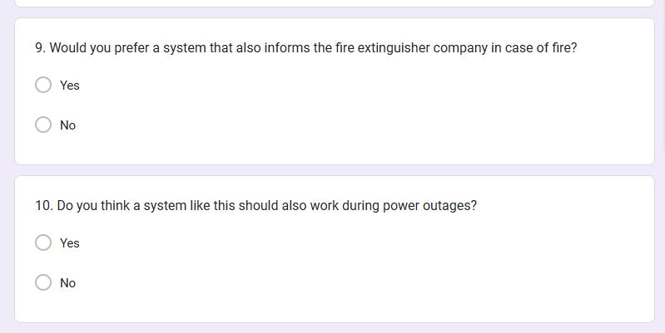

Figure 13- Question 09,10

Figure 14- Question 11,12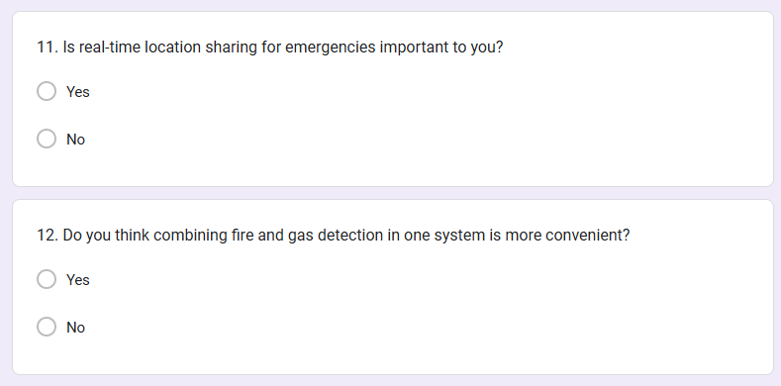

Figure 15- Question 13,14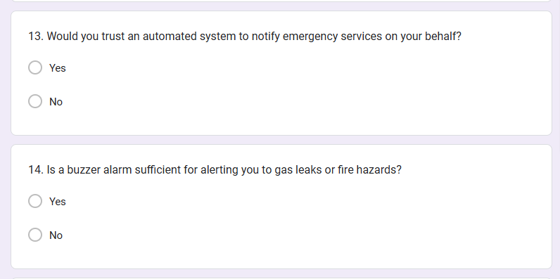

Figure 16- Question 15,16,17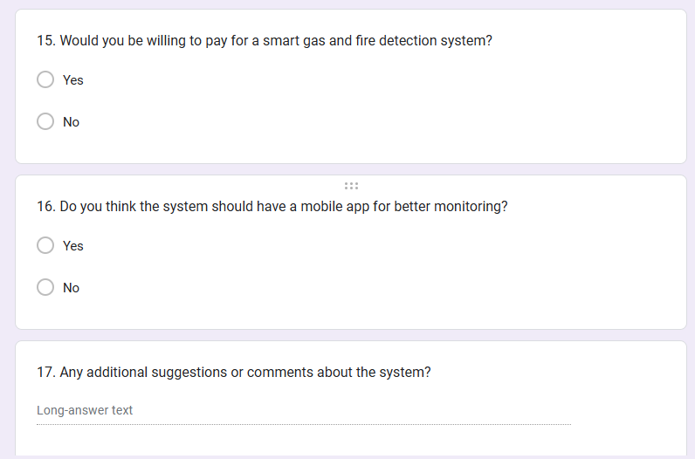

## **3.3.2 Interviews question**

The most commonly used, and usually most useful, fact-finding procedure is interviews. We can hold interviews to gather information face-to-face. Finding facts, verifying those facts, explaining these released facts, generating enthusiasm, engaging the end user, identifying needs, gathering ideas and opinions are some of the uses of interviewing. The practice of interviewing requires proper communication skills in order to deal with people having varied values, priorities, opinions, motivations, and personalities. Qualitative data was collected through an interview process with potential stakeholders of the Arduino-based Smart Gas Leakage and Fire Detector System with a gas-booking system. Information sources included interviewing potential users and industry professionals, together with safety experts, so that detailed information on end user requirements, safety, and expectations could be unearthed. The questions were designed to address various aspects of gas leakage and fire safety, automation, and user convenience.

## **3.3.2.1 Sample Interview Questions:**

1. What is your knowledge base with regard to fire hazards associated with gas leak prevention in both residential and industrial environments?
2. Have you encountered or had any incident with gas leakage or fire? If yes, how was it handled?
3. Are you currently using any gas leak or fire detection systems? If so, what is the shortcoming or difficulty you are experiencing with them?
4. How effective do you think these traditional safety systems are, in regards to gas leaks and fire hazards?
5. How do you feel about using an automated system for detecting gas leaks and fire hazards?
6. What are your expectations from an automated safety system in terms of reliability, accuracy, and ease of use?
7. Would you want to receive emergency alerts through mobile apps, SMS, or calls? Why?
8. How important is real-time monitoring of gas levels and fire detection to you?
9. Do you feel that an auto-gas-booking feature is essential? Why or why not?
10. Are there any specific features or functionalities you would like to see in the system?
11. What price range would you consider reasonable for implementing this system in your home or workplace?

## **3.3.2.2 Purpose of the Questions**

These interview questions were to understand the user's perspective, identify the gaps in existing solutions, and collect actionable feedback that could help design an effective and user-friendly system. The insights from these interviews, by nature qualitative, had a very instrumental role in shaping the development of the project to ensure it addressed real-world needs and expectations.

# **3.4 Requirement Analysis**

Surveys questionnaires for people Analysis

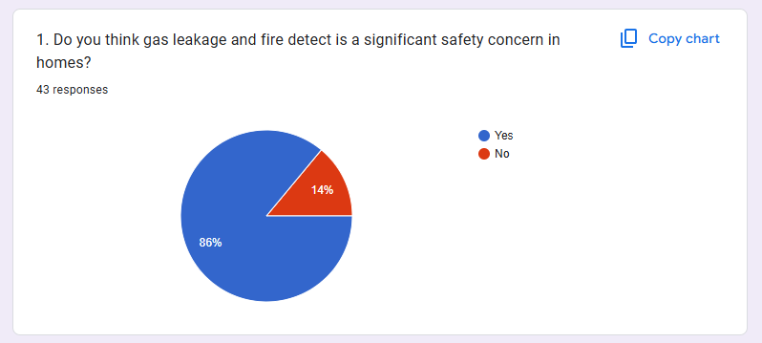

Figure 17- Answers 01

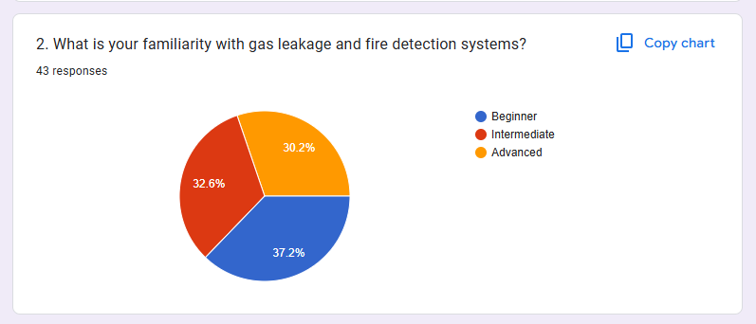

Figure 18- Answers 02

Figure 19 - Answers 03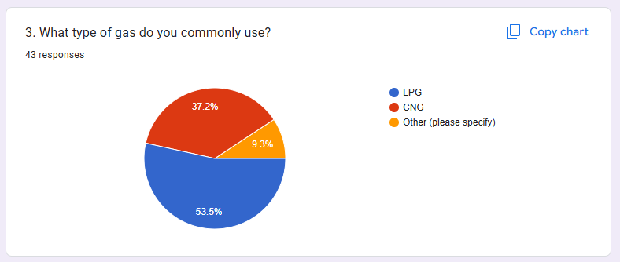

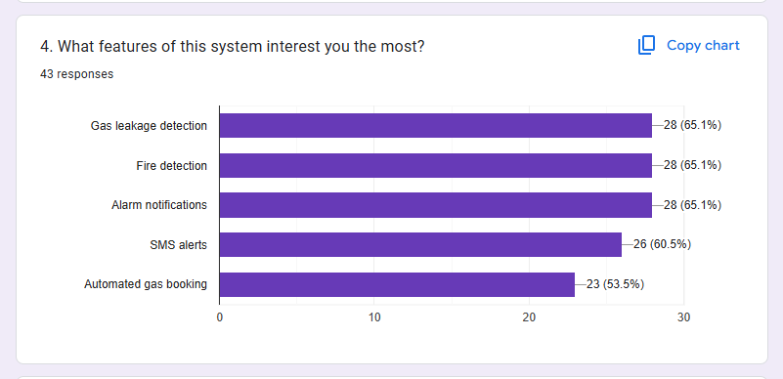

Figure 20 - Answers 04

Figure 21- Answers 05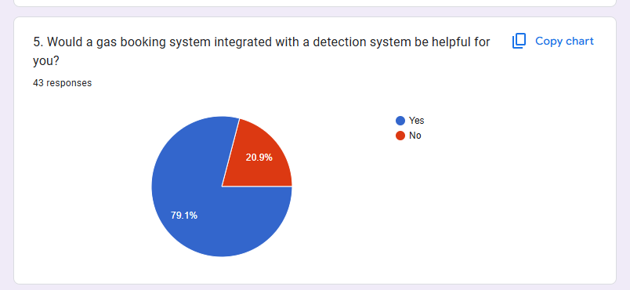

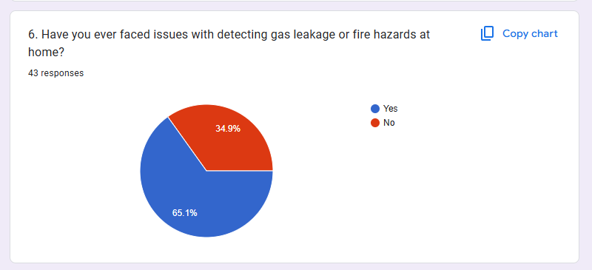

Figure 22- Answers 06

Figure 23 - Answers 07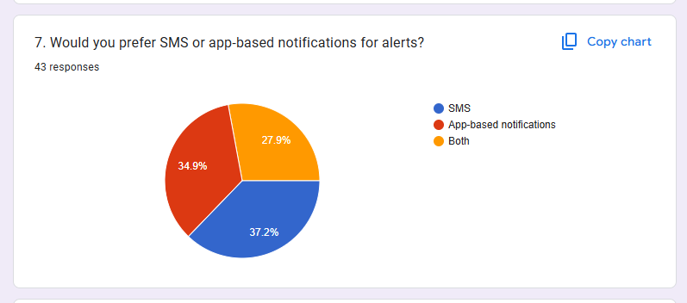

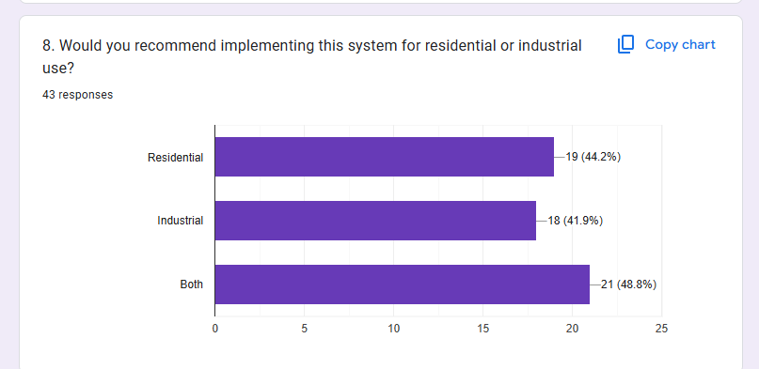

Figure 24 – Answers 08

Figure 25- Answers 09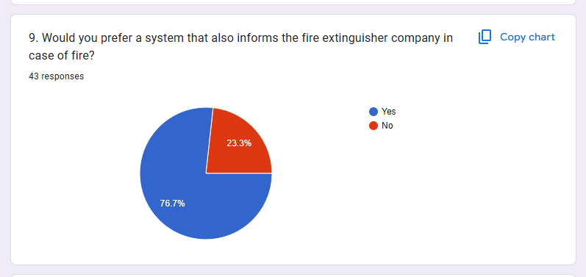

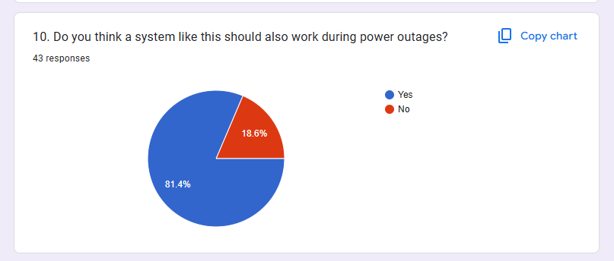

Figure 26- Answers 10

Figure 27- Answers 11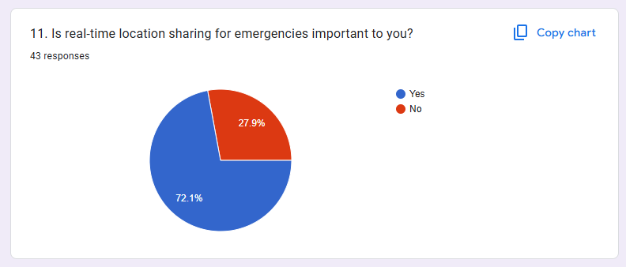

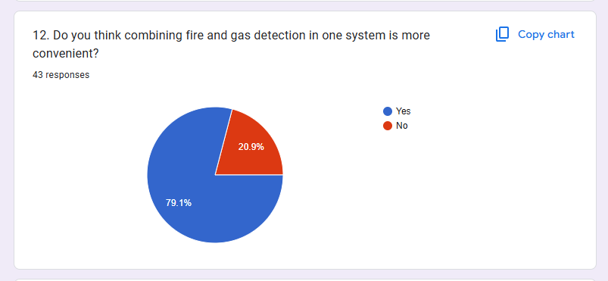

Figure 28- Answers 12

Figure 29- Answers 13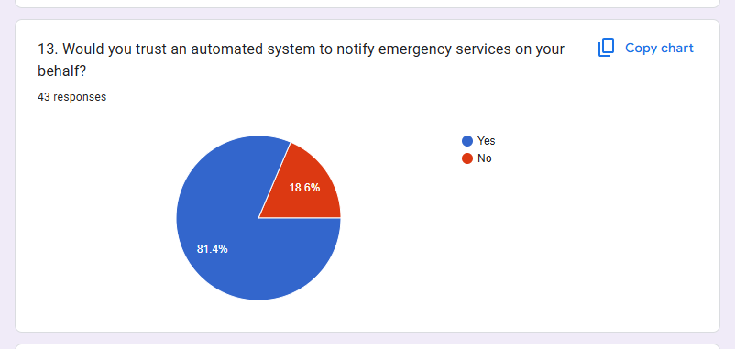

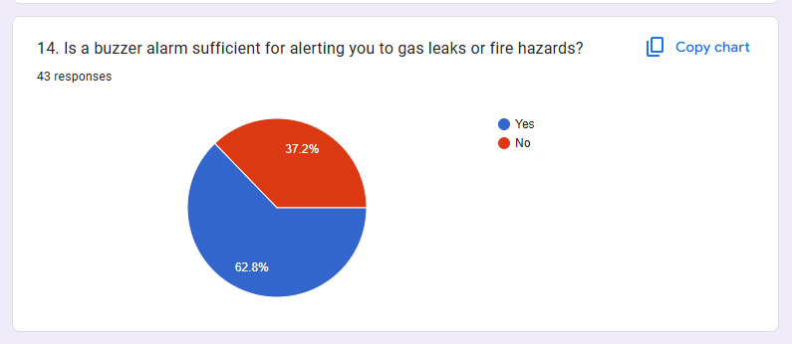

Figure 30- Answers 14

Figure 31- Answers 15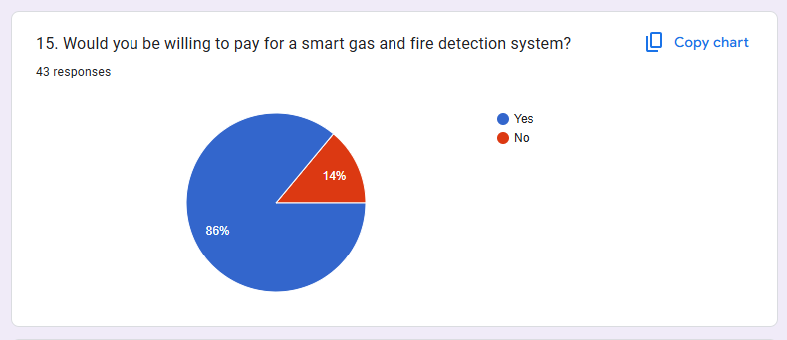

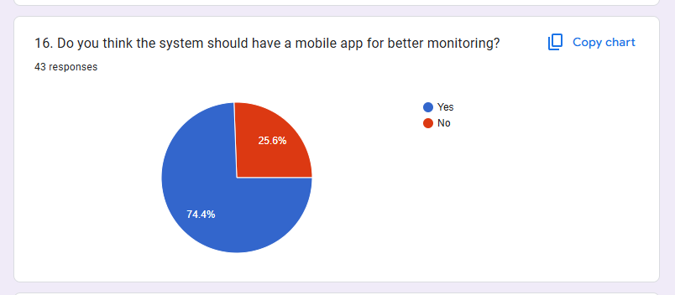

Figure 32- Answers 16

Figure 33- Answers 17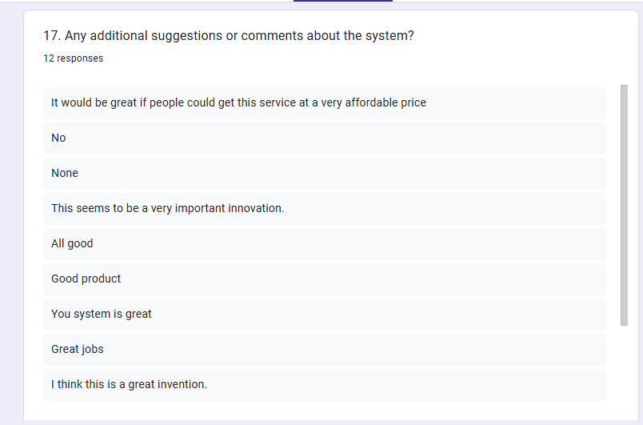

# **3.5 Functional Requirement**

An Arduino-based smart gas leak and fire detection system with gas separation system is designed to perform specific tasks that ensure effective detection, monitoring, and notification of gas leaks and fire hazards. These requirements outline the basic functionalities that the system must perform to meet its objectives.

1. **Gas and Fire Detection:** The system must be able to accurately detect gas leaks (LPG and methane) and fire hazards. This includes using gas sensors such as MQ2 and MQ5 and a fire sensor to capture and identify dangerous levels.
2. **User Notifications:** When a gas leak or fire is detected, the system should send instant notifications to the user via a mobile app, text messages, and phone calls. This ensures that the user is notified immediately, even if the system is not nearby.
3. **Gas Booking System:** The system should monitor the gas cylinder levels using a weight sensor. When the gas level in the cylinder is low, the website and display connected to the system informs the by of the gas level, thus inform the need for refilling and contacting suppliers. This helps to reduce and avoid the hassle of manually checking gas levels.
4. **Activation of exhaust fans:** If a gas leak is detected, the system should activate an exhaust fan to ventilate the area and disperse the gas from the room, reducing the risk of accumulation and explosion.
5. **LCD display for real-time monitoring:** The system should display critical information such as gas levels, valve status (on/off), and safety alerts on an LCD screen. This allows users to check the system status at a glance.
6. **Activation of Safety Mechanisms:** The system should also shut off gas valves with a servo motor mechanism to prevent further leakage.
7. **Integration with Emergency Services:** In the event of an emergency, the system should notify relevant authorities such as fire departments or gas suppliers with location details for timely intervention.
8. **System Reset and Manual Control:** Users should be able to reset the system after an alarm and manually control specific components, such as turning the gas valve on/off or turning on the exhaust fan.
9. **Self-Test and Calibration:** The system must perform periodic self-tests to ensure that the sensors are operating correctly, and the sensors must be recalibrated to maintain accuracy.
10. **Energy Efficiency:** The system must operate efficiently to minimize power consumption, and support both mains power and battery backup to ensure uninterrupted operation.

These functional requirements enable the system to detect and remediate gas leakage and fire hazards, providing automated safety measures and notifications to the users. The project realizes the safety, convenience, and operational reliability of residential, commercial, and industrial settings.

# **3.6 Non-Functional Requirement**

An Arduino-based smart gas leak and fire detection system with a gas separation system must also meet several non-functional requirements to ensure that the system operates efficiently, reliably, and in a user-friendly manner. These requirements define the quality attributes and constraints of the system and support its overall functionality.

1. **Reliability:** The system should operate uninterruptedly and precisely in the detection of gas leakage and fire hazards. For reliability, it is very crucial that it works correctly at the time of an emergency.
2. **User friendliness:** The system should be user-friendly for users, both in understanding and operating. The notification and display interface should be intuitive so that users can respond to alerts quickly.
3. **Scalability:** The system should be adaptable to different environments, whether in small homes or large commercial settings. This may mean adding more sensors for wider coverage.
4. **Low power consumption:** The system must consume minimal power to be efficient and reduce maintenance requirements, especially if it relies on battery power for continuous operation.
5. **Security:** Because the system will be working on mobile networks or Wi-Fi, the data should be transmitted securely to avoid unauthorized access to notifications and control commands.
6. **Maintainability:** The system should be easy to maintain, with simple procedures for sensor calibration, component replacement, and software updates.
7. **Performance:** The system must detect and respond to gas leaks and fire hazards within a short time, typically less than 2-3 seconds, to ensure timely warnings and preventive measures.
8. **Compliance:** The system must comply with relevant safety, environmental, and telecommunications standards to ensure legal operation and safe use in residential, commercial, and industrial environments.

These non-functional requirements ensure that the system delivers high quality, safety and usability. By meeting these standards, the system becomes a reliable and efficient solution for detecting gas leaks and fire hazards, while meeting user expectations for safety and convenience.

**3.7 Methodology for the System Development**

A structured methodology is followed in order to ensure effective design, implementation, and evaluation of the system and finally come up with an Arduino-based intelligent gas leakage and fire detection system integrated with a gas separation mechanism. The requirements gathering and analysis were the first stage to clearly define the requirements: identification of gas leakage, hazards of fire, automatic alerting. The hardware components appropriate for this project were also researched: gas sensors, fire sensors, the Arduino Uno board, and communication modules to ensure each was reliable and cost-effective. During this system design phase, there were created blueprints: block diagrams, flowcharts, and circuit diagrams ways to visually represent the interactions of the hardware and software components. [10] When the design was ready, hardware development truly got down to assembling sensors, a microcontroller, an LCD display, and a SIM module that would be integrated into one functional prototype. Software development, in parallel, is being done within the Arduino IDE environment by writing the code to be used in processing data from sensors, triggering the display of security alerts on the LCD, and delivering notifications using SMS or mobile apps. Testing and calibration were critical steps in ensuring that the sensors have to detect gas leak and fire hazards with minimized false alarm possibility. Its performance was validated through testing; adjustments were made until optimal reliability was achieved. Finally, after testing, the integrated system was assured to meet all requirements under a well-performing structure of hardware and software working together in perfect harmony. The last step in implementation was the placement of the system in a test environment where its performance in real life could be evaluated and tested, and feedback could be collected for future improvements. Also, detailed documentation was created to help users operate and maintain the system, including instructions on how to perform sensor calibrations and apply software updates.[8] This systematic approach guaranteed the development of a secure, user-friendly, and efficient system that achieved its objectives of improving the safety and convenience of ITS.

**3.7.1 Selected Methodology**



Figure 34: Selected Methodology

1. **Requirement Gathering and Analysis:**

* First, specific system requirements were identified, such as gas leakage detection, fire hazards, and alerting users through alarms.
* A survey of existing sensors, microcontrollers, and other parts was performed in order to choose the best fit for the project.

1. **System Design:**

* Design the circuit by connecting the gas sensor, fire sensor, weight sensor, temperature sensor, servo motor, buzzer, LCD display, GSM module, Wi-Fi module, and exhaust fan to the Arduino.
* And even if there is no gas leakage here, if the operator needs to stop the operation of the gas pipes for any reason, creating a suitable able manually switched opportunity for the systems. (manually on/off gas supply).

1. **Hardware Development:**

* The main components, including MQ2 and MQ5 gas sensors, fire sensors, a load cell sensor, and an Arduino Uno board, LCD display, and GSM module, were assembled to create the hardware prototype.
* The sensors were carefully calibrated to ensure accurate detection of gas leaks and fire hazards.

1. **Software Development:**

* The system was programmed using Arduino IDE. The code was written to read data from sensors, trigger alerts and notifications when a gas leak or fire is detected, display real-time information on the LCD, and send messages or calls via the GSM module for emergency notifications.
* A website was developed to manage gas reservations and view alerts remotely.

1. **Programming:**

* Write the Arduino code to read gas sensor, fire sensor, weight sensor, temperature sensor data, control the servo or stepper motors, and manage the LCD display.
* Configure the Wi-Fi module to send notifications to a web site and initiate phone calls and text messages.
* Program the exhaust fan to activate and extract gas when a leak is detected.

1. **Testing and Calibration:**

* Calibrate the gas sensor, weight sensor, temperature sensor and fire sensor for accurate detection.
* Test the system navigation and ensure it moves effectively towards gas sources.
* Validate the alert system, ensuring reliable notifications via buzzer, LCD display, web site, phone calls, and text messages.

1. **Integration and Optimization:**

* Integrate all components into a cohesive system.
* Optimize the systems navigation and response times for efficiency.
* Ensure the LCD display shows accurate gas levels, valve status, and safety information.

This step-by-step methodology ensured that the system was developed efficiently and achieved its goals of improving security and convenience for users.

# **CHAPTER 4 - DESIGN**

## **4.1 Introduction**

This chapter shows the detailed design framework of the Arduino-driven smart gas leakage and fire detection system with a gas separation mechanism. The design methodology follows an object-oriented paradigm to enhance clarity and systematic organization in illustrating the structural components, interactions, and functional capabilities of the system. Essiential diagrams, such as use case diagrams, sequence diagrams, and class diagrams, are used to depict the functionalities of the system visually and to outline the interactions among different components in realizing the project objectives. The design phase involves breaking down the system's components and functionalities into smaller modules that work together in harmony. From gas detection to fire alarm systems and LPG gas separation, each element is addressed with specific diagrams and narratives on how it works and why it is important in the overall system. The architectural layout of the Arduino-based intelligent gas leakage and fire detection system, which includes a gas separation mechanism, integrates various sensors, control units, and communication modules under the governance of the Arduino Uno microcontroller. The design has been engineered to detect gas leaks and possible fire hazards, raise alarms, monitor gas concentrations for ventilation of affected areas, and pave the way for automation of isolation processes. Each component in the system serves a specific purpose to ensure a safe and self-sustaining environment.

# **4.2 System Design Process**

## **4.2.1 Use Case Diagram**

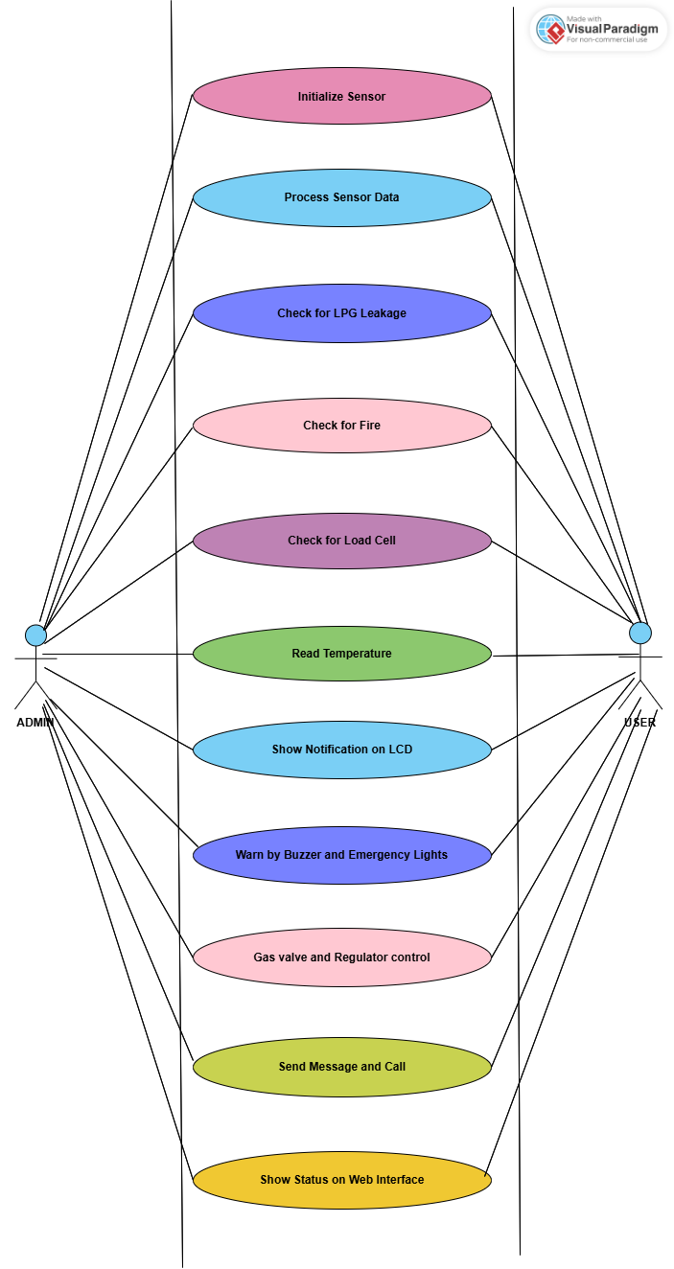Figure 35 - Use Case Diagram

## **4.2.2 Data Flow Diagram**

Figure 36 - Data Flow Diagram

## **4.2.3 Block Diagram**

Figure 37 - Block Diagram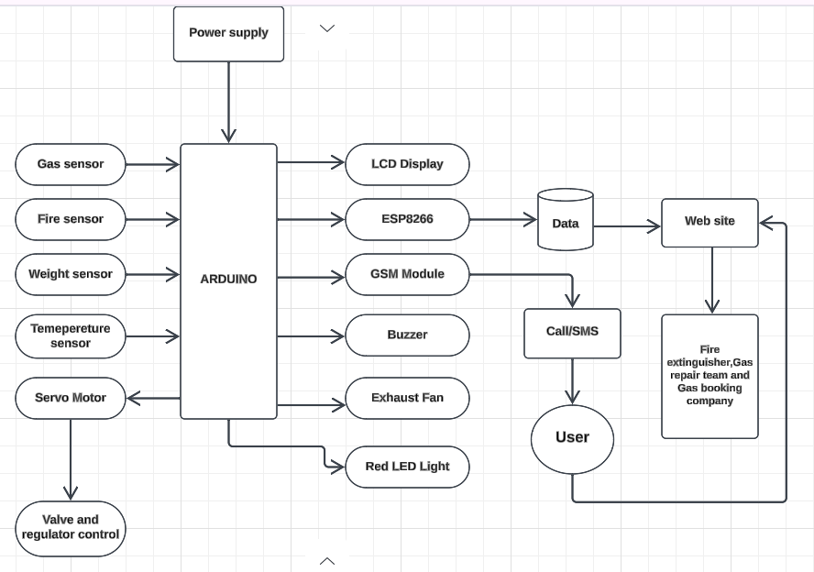

## **4.2.4 Sequence Diagram**

**MQ2 and MQ5 Sensor**

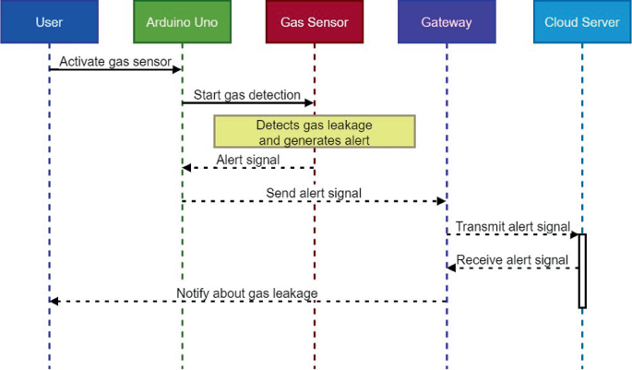

Figure 38 - Sequence Diagram (MQ2, MQ5 Sensors)

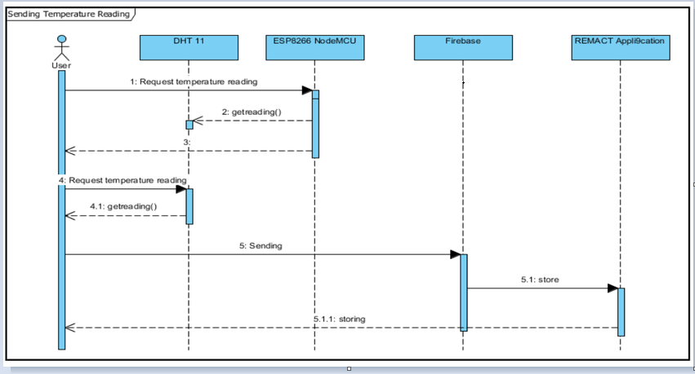**DHT 11 Sensor**

Figure 39 - Sequence Diagram (DHT11 Sensor)

**SIM900A GSM Module**

Figure 40 - Sequence Diagram (GSM Module)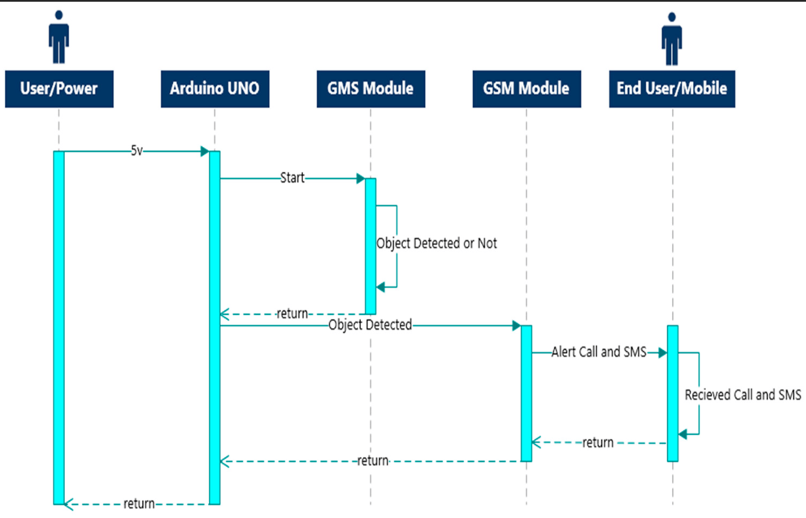

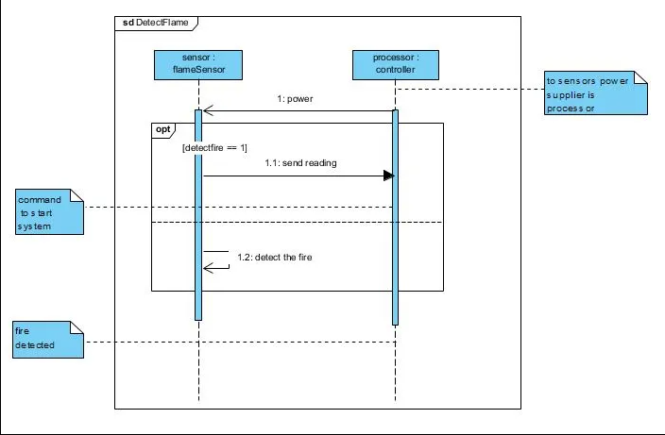**Flame Sensors**

Figure 41 - Sequence Diagram (Flame Sensor)

## **4.2.5 Activity Diagram**

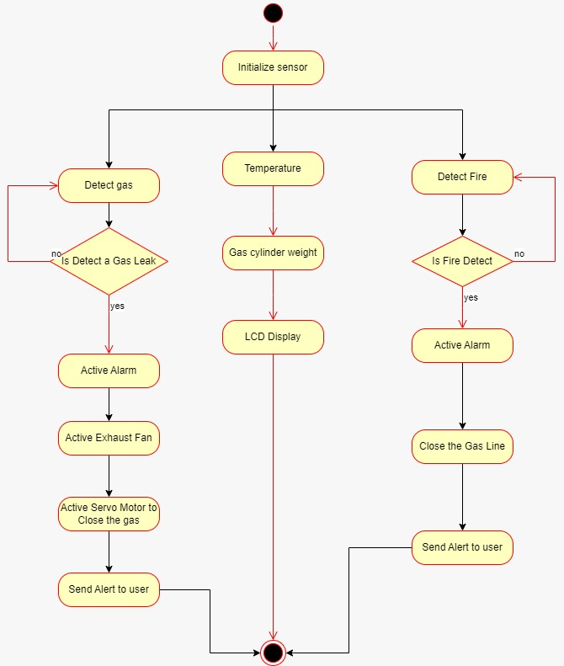

Figure 42 - Activity Diagram

**4.2.6 Flow chart**

**Web Page**

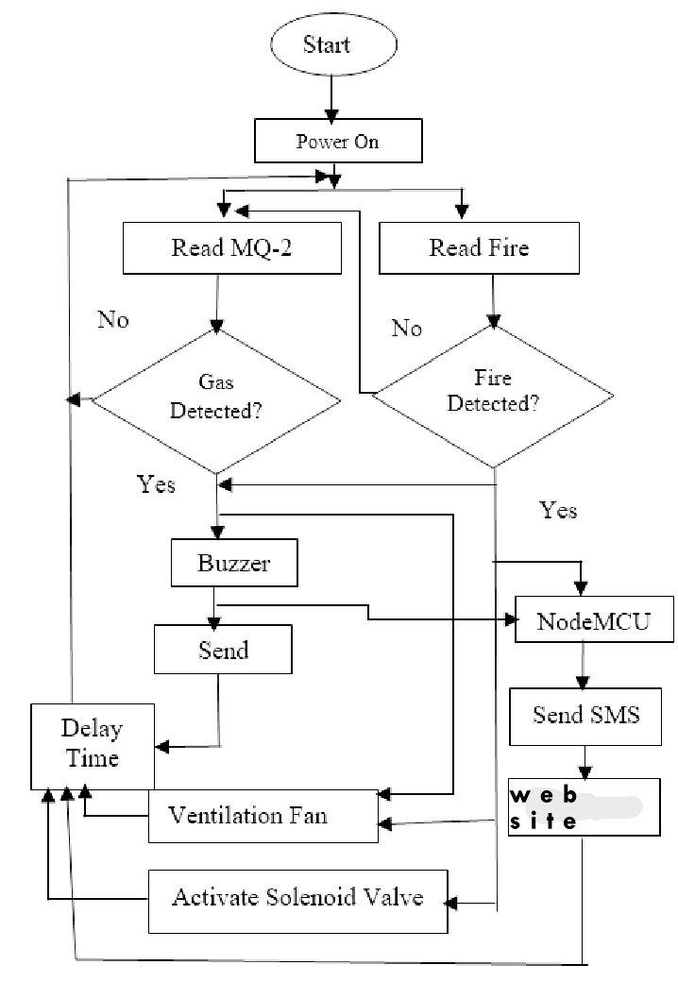Figure 43 - Flow chart

## **4.2.7 Design Diagram**

Figure 44 - Design Diagram

**Temperature Sensor**

**Flame Sensor**

**Load Cell Sensor**

## **4.2.8 Circuit Diagram**

Figure 45 - Circuit Diagram

Flame Sensors

MQ2 Gas Sensors

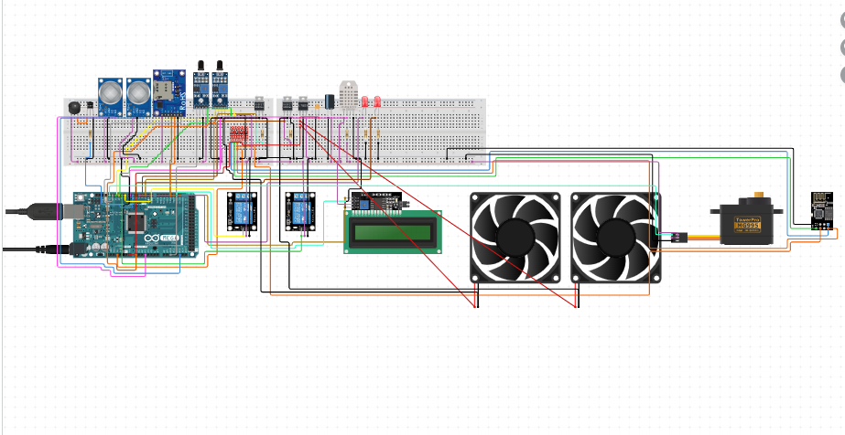

I2C Convertor

NodeMCU

Servo Motor

Arduino Uno Board

Exhaust Fan

LCD Display

Relay Module

LED

DHT11

Buzzer

GSM Module

# **4.3 Interface Design**

## **4.3.1 Mock Screen of the System**

**Flame Sensors**

Figure 46 - Flame Sensor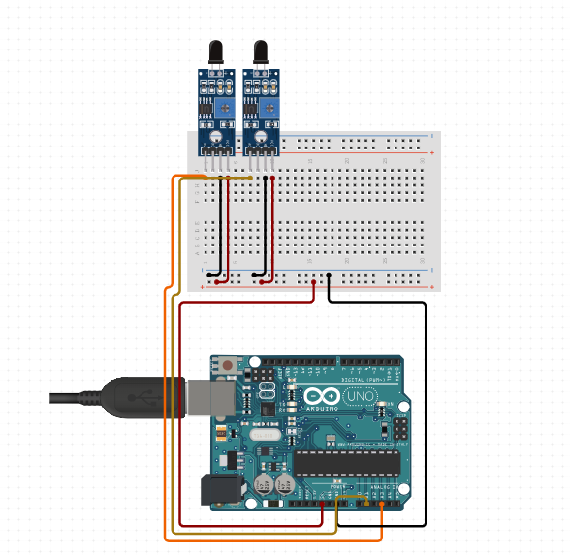s

**MQ2 Gas Sensors**

Figure 47 - MQ2 Gas Sensors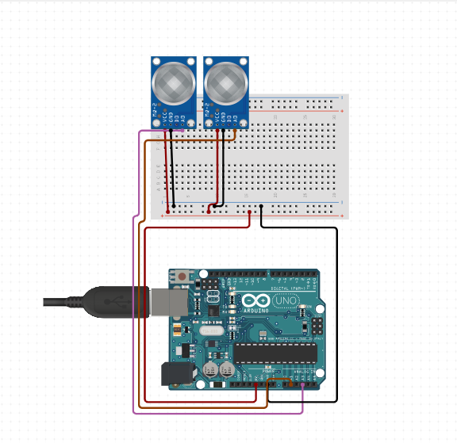

**Exhaust Fan and Relays**

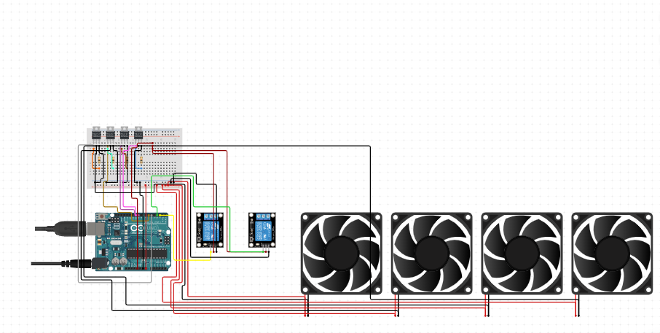

Figure 48 - Exhaust fan and Relays

**Emergency Bulb and Relay**

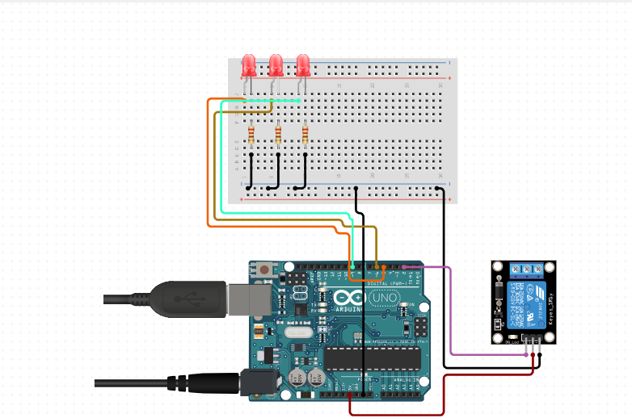Figure 49 - Emergency Bulb and Relay

**Buzzer**

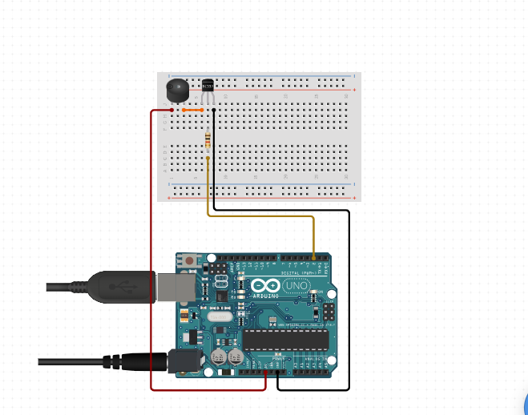

Figure 50 - Buzzer

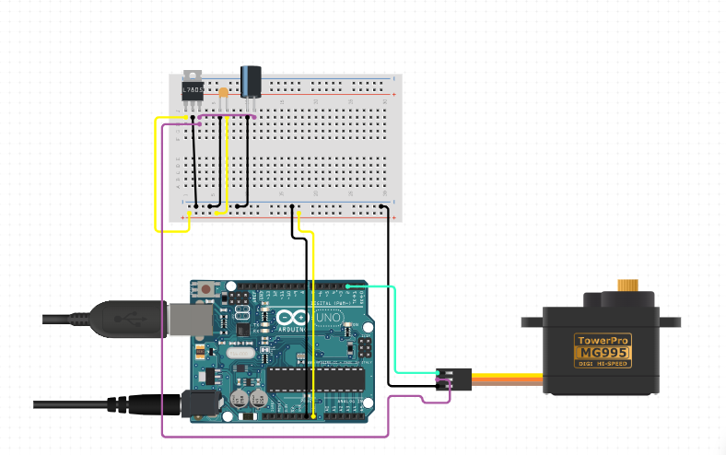**Servo Motor**

Figure 51 - Servo Motor

**Servo Motor and Gas Regulator**

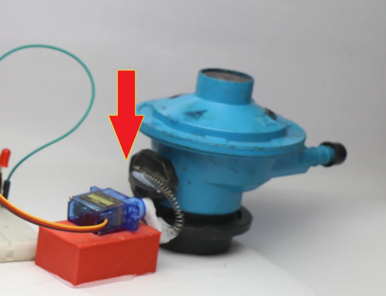

Figure 52 - Servo Motor and Gas Regulator

**Node MCU Board and MQ2 Gas sensor**

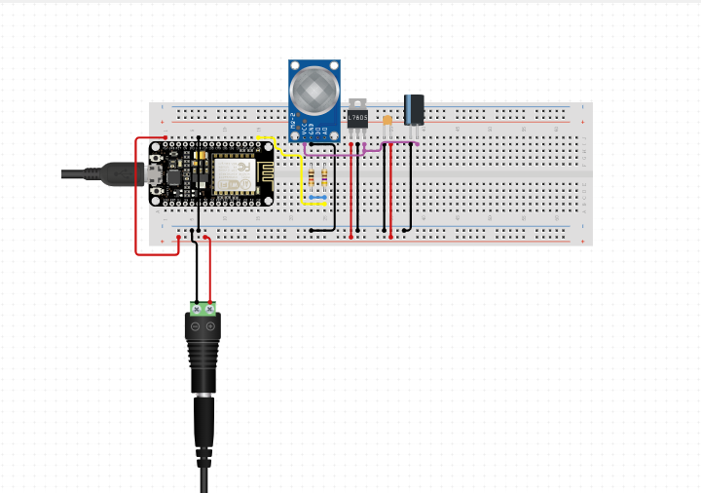

Figure 53 - Node MCU and MQ2

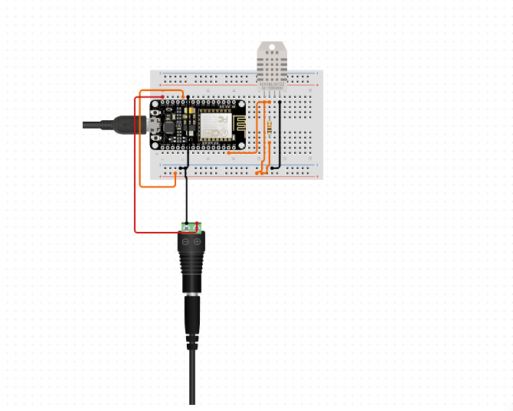**Node MCU Board and DHT11 sensor**

Figure 54 - Node MCU Board and DHT11 sensor

**Node MCU Board and 5kg Load Cell sensor**

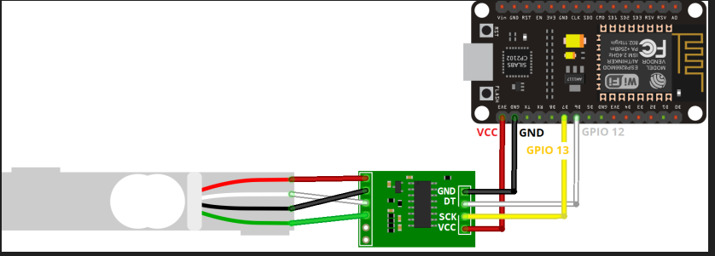

Figure 55 - Node MCU and Load Cell Sensor

**Node MCU Board and LCD Display**

Figure 56 - Node MCU and LCD Display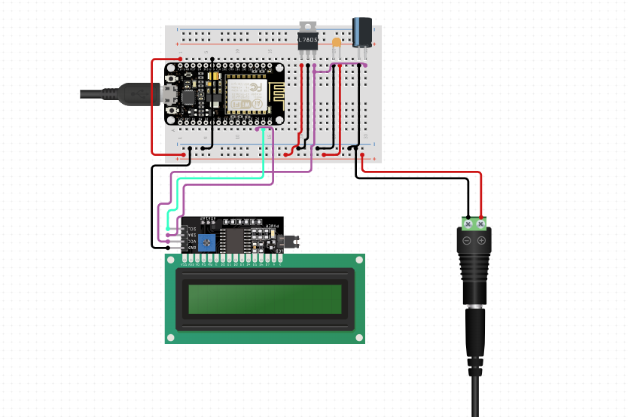

# **4.4 Hardware Components**

## **Arduino Uno Board**

The Arduino Uno is a open source microcontroller board based on the ATmega328 chip. This Board has 14 digital input/output pins, 6 analog input pins, Onboard 16 MHz ceramic resonator, Port for USB connection, Onboard DC power jack, An ICSP header and a microcontroller reset button. It contains everything needed to support the microcontroller. Using the board is also very easy, simply connect it to a computer with a USB cable or power it with DC adapter or battery to get started. The board can operate on an external supply of 6 to 20 volts. If supplied with less than 7V, however, the 5V pin may supply less than five volts and the board may be unstable. If using more than 12V, the voltage regulator may overheat and damage the board. [12]

**Specification**

* Microcontroller: **ATmega328**
* Operating Voltage: **5V**
* Input Voltage: **7-9V**
* Digital I/O Pins: **14** (of which 6 provide PWM output)
* Analog Input Pins: **6**
* DC Current: **40mA**



Figure 57 - Arduino Uno Board

## **ESP 8266 Wi-Fi Board (Node MCU Board)**

The ESP8266 Node MCU is a low-cost Wi-Fi microcontroller module that allows for easy integration of Internet of Things (IoT) applications. It is based on the ESP8266 Wi-Fi SoC (System on Chip) manufactured by Espressif Systems, and comes with an open-source firmware called Node MCU that allows you to write and run Lua scripts or programs. The NodeMCU firmware is open source and allows programming in Lua, but the module can be programmed using the Arduino IDE and MicroPython, which gives it versatility in different programming environments. It features built-in Wi-Fi capabilities that comply with the 802.11 b/g/n standards, making it ideal for wireless communication in IoT projects. The module has several GPIO (General Purpose Input/Output) pins for connecting sensors and actuators. It supports analog input via a single analog pin (A0) and has a variety of communication protocols including UART, SPI, and I2C. This makes interfacing with other peripherals easy. Powered via a USB cable (5V) or a 3.3V pin, NodeMCU is widely used in home automation, sensor monitoring, and various IoT systems due to its flexibility and ease of use. Its applications range from smart home systems and plant watering systems to gas leak detectors and environmental monitoring systems, providing seamless connectivity to the Internet with minimal additional hardware. [13] [14]

**Specification**

* 3.3V operating voltage, internal voltage regulator allows 5V on power input
* USB – micro USB port for power, programming and debugging
* Serial Wi-Fi transmission rate: 110-460800bps
* Available Firmware for Arduino IDE

The ESP8266 board is use for send data to cloud and show values in a web page. MQ2 sensor, Load cell sensor and DHT11 sensor has connected to the ESP8266 board.

## **SIM900A GSM Module**

GSM is a mobile communication modem, which is the global system for mobile communications. A GSM modem is a specialized modem that accepts a SIM card and acts like a mobile phone. From the perspective of a mobile operator, a GSM modem looks like a mobile phone. When a GSM modem is connected to a computer, this allows the computer to communicate with the GSM modem over the mobile network. These GSM modems are widely used to provide mobile internet, and in many of them, the internet connection can be used to send and receive text messages. It is used for the transmission of mobile voice and data services operating in the 850 MHz, 900 MHz, 1800 MHz and 1900 MHz frequency bands. The purpose of the GSM module is to notify the user about the gas. The type of leaky GSM module used in this system is the SIM900A GSM module. The GSM module allows the microcontroller to communicate with the mobile phone via UART. A SIM card, such as a mobile phone, is required to enable communication with the network. Also, they have an IMEI (International Mobile Equipment Identity) number which is used to identify mobile phones. Once a gas leak is detected, a text message is sent to the user number from the inserted SIM card. [15]

Figure 58 - SIM900A GSM

## **DHT11 Temperature and Humidity Sensor**

The DHT11 consists of a humidity sensing component and a thermistor to measure the surrounding air. It uses a microcontroller inside to convert the analog signals from the thermistor and humidity sensor into a digital format for easier interfacing with other electronic components. This is a very popular, ultra - low-cost digital temperature and humidity sensor. It uses a capacitive humidity sensor, and a thermistor to measure the surrounding air temperature. The result is available via a digital signal on the data pin (no analog input pins needed). [16]

**Specification**

* Power supply voltage: 3.3~5.5V DC
* Output: The single Bus digital signal
* Measuring range: 20-90%RH humidity
* Temperature: 0~50°



## **Flame Sensor**

A flame sensor is a device that detects the presence of a flame or fire. It works by sensing the infrared (IR) or ultraviolet (UV) light emitted by a flame. Flame sensors are widely used in security systems to detect fires and prevent disasters. They are commonly found in firefighting robots, gas burners, and industrial applications. [17]

**Specification**

* Detection Wavelength: 760 nm to 1100 nm (Infrared light)
* Detection Angle: Approximately 60°
* Voltage Supply: 3.3V to 5V
* Temperature Range: -25°C to 85°C
* Digital Output: High (when no flame detected), Low (when flame detected)
* Analog Output: Varies based on flame intensity

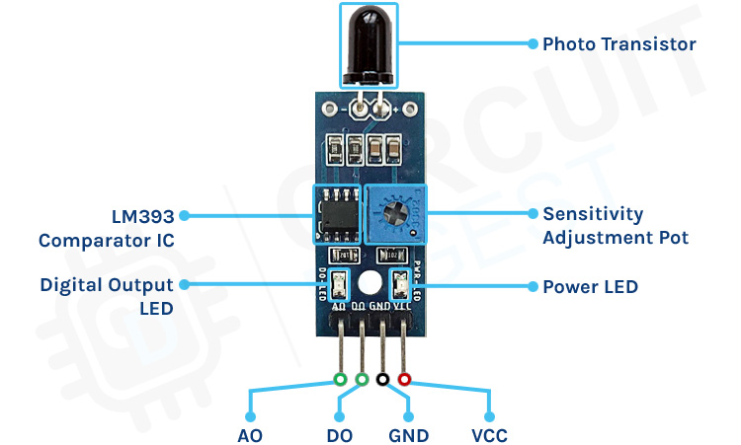

Figure 59 - Flame Sensor

## **MQ2 Gas sensor**

The MQ2 sensor is one of the most widely used in the MQ sensor series. It is a MOS (Metal Oxide Semiconductor) sensor. Metal oxide sensors are also known as Chemiresistors because sensing is based on the change in resistance of the sensing material when exposed to gasses. The MQ2 gas sensor operates on 5V DC and consumes approximately 800mW. It can detect LPG, Smoke, Alcohol, Propane, Hydrogen, Methane and Carbon Monoxide concentrations ranging from 200 to 10000 ppm. The MQ2 is a heater-driven sensor. It is therefore covered with two layers of fine stainless-steel mesh known as an “anti-explosion network”. It ensures that the heater element inside the sensor does not cause an explosion because we are sensing flammable gasses. [18] MQ2 is widely used in applications such as smoke detection, LPG leak alarms, fire protection systems, and air quality monitoring systems.

**Specification**

* Operating Voltage: 5V
* Operating Current: 150 mA
* Output: Analog and Digital
* Detection Range: 200–10,000 ppm
* Analog Voltage Range: 0–5V

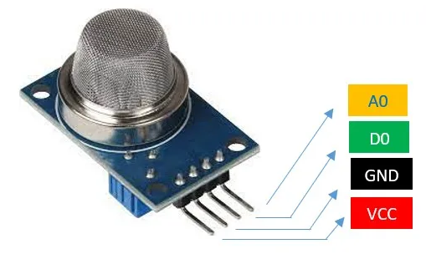

Figure 60 - MQ2 Gas Sensor

## **Relay Module**

A relay module is an electronic device that acts as a switch, allowing low power control circuits such as microcontrollers or sensors to control high power devices such as lights, motors or home appliances. It operates by using an electromagnetic coil which, when energized by a small electrical signal, closes or opens a mechanical switch that controls the associated high-power circuit. Relay modules typically provide isolation between the control and high-power circuits, ensuring that the low voltage control side remains safe from electrical surges or faults. These modules are widely used in automation, IoT and home control systems to enable remote or automatic switching of AC or DC devices. [19] Here we use it for the operation of exhaust fans.

**Specification**

* Operating Voltage: 5V or 12V (depending on the module)
* Trigger Voltage: 3.3V or 5V (logic-level compatible)
* Current Draw: ~70–90 mA per channel (coil current)
* Load Voltage: Up to 250V AC / 30V DC (depending on the relay)
* Load Current: 10A (typical, check the relay rating)
* Channels: 1, 2, 4, 8, or more

Figure 61 - Relay Module

## **5 Kg Load Cell Sensor**

A load cell is a type of transducer that converts a force or load into an electrical signal. It works based on the principle of measuring the strain that deforms when a load is applied. This deformation causes a change in electrical resistance, which is then converted into a measurable output. Load cells are widely used in weighing systems such as digital scales and industrial applications that require precise measurement of weight or force. They come in different types including compression, tension and shear beams depending on the specific application. Load cells are known for their high accuracy and reliability in weight measurement, they are essential in industries like manufacturing, transportation and automation. The load cell is the sensor at the heart of electronic scales or weighing machines. This sensor senses the weight of the items and displays it with the help of Arduino and LCD. It has different principles like load cell based on fluid pressure, based on elasticity, based on piezoelectric effect, etc. Basically, it is used to sense the weight of items like liquid pressure. Here we use it to find out how much gas is in the gas cylinder. [20]

**Specification**

* Capacity: 5 kg
* Accuracy: ±0.03% of full scale
* Rated Output: ~1 mV/V to 2 mV/V (depends on the specific model)
* Excitation Voltage: 5V DC (recommended); up to 10V DC (maximum)

Figure 62 - Load Cell Sensor

## **Exhaust Fan**

In smart gas leak detector systems, exhaust fans play a critical role in ventilating the area to remove harmful gases. Here's how they work in such systems. When a gas sensor (like MQ2 or MQ5) detects a gas leak, it sends a signal to the microcontroller that processes the data. If the gas concentration reaches a dangerous level, the system issues an alarm, which means sending an alert or notification. Simultaneously, the microcontroller activates the exhaust fan which is connected through a relay module. The exhaust fan then works to suck gas from the enclosed space and exhaust it outside, reducing gas concentration and preventing build-up. This helps the leaked gas dissipate quickly, improving safety by reducing the risk of fire or explosion. In smart systems, the exhaust fan can continue to run until air levels fall below a safe limit, after which the system automatically turns the fan off. This automation ensures quick and effective ventilation in the event of a gas leak.

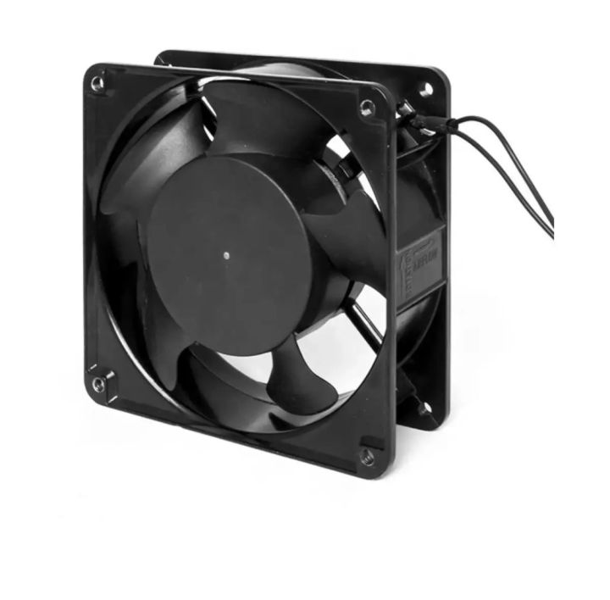

Figure 63 - Exhaust Fan

## **LCD Display**

A 16x2 LCD display is a popular character-based liquid crystal display module. It consists of two rows, each row of which can display 16 characters, for a total of 32 characters. Each character consists of a 5x8 dot matrix. These displays are widely used in embedded systems, IoT, and electronics projects due to their simplicity, low power consumption, and affordability. The display typically uses the Hitachi HD44780 controller or a compatible chip and communicates via 4-bit, 8-bit parallel interfaces, or I2C with an additional interface module. Here we use it to show the system temperature, the amount of gas in the cylinder and the amount of gas leaked. [21]

**Specification**

* Operating Voltage: 4.7V - 5.3V DC
* Interface: Parallel (4-bit or 8-bit), or I²C (with PCF8574 module)
* Controller: HD44780 or compatible
* Current Consumption: ~2mA (without backlight), ~20mA (with backlight)
* Operating Temperature: 0°C to 50°C

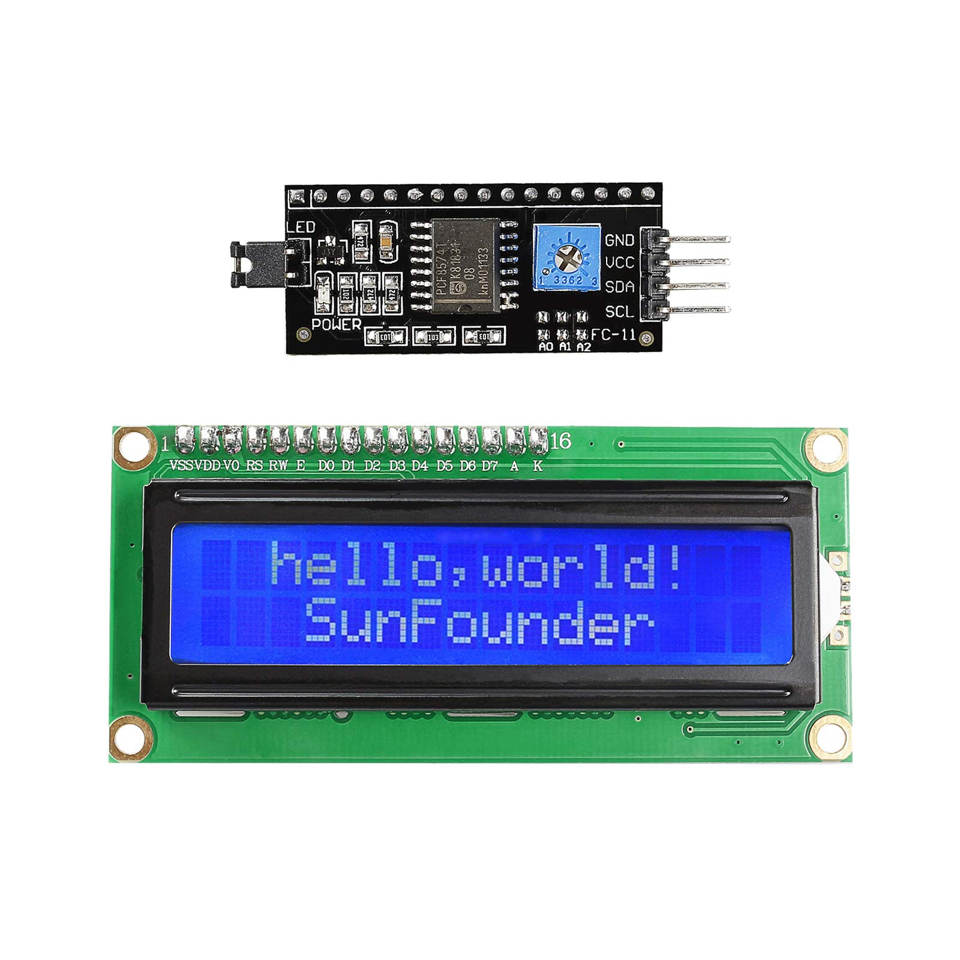

Figure 64 - I2C Converter and LCD Display

## **Buzzer**

A buzzer or pager is a mechanical or non-mechanical sound device. It is used as feedback in alarms, notifications, and user interfaces. Buzzers can be active (self-contained, requiring only a power supply to produce a tone) or passive (requiring an external driver circuit to generate the sound). A buzzer has 2 pins. It is a simple and inexpensive design used in various applications such as car/truck meters, computers, and alarm clocks. Objects generate electricity when mechanical pressure is applied to the device, and vice versa. A buzzer is an electrical device that emits a loud sound and is used for signaling. A buzzer has a piezo disc and an oscillator. When the buzzer is powered, the oscillator generates a frequency of about 2-4 kHz and the piezo element vibrates and produces sound. As soon as a gas leak is detected, the buzzer automatically sounds to notify users about the gas leak. [4]

**Specification**

* Type: Active or Passive
* Operating Voltage: 3V - 12V (common range: 5V)
* Operating Current: 10mA - 30mA
* Sound Frequency: 2kHz - 4kHz (depending on the model)
* Sound Pressure Level: ~85dB - 95dB @ 10cm
* Connection Type: Two-pin connection: Positive (+) and Negative (-)



Figure 65 – Buzzer

## **Servo Motor**

A servo motor is a self-contained electrical device that moves parts of a machine with high efficiency and great precision. In simpler terms, a servo motor is a BLDC motor with a sensor for positional feedback. This allows the output shaft to be moved to a particular angle, position, and velocity that a regular motor cannot do. However, a servo motor is only one part of a closed-loop motion control system. A complete motion system includes an amplifier, control circuit, drive gears, potentiometer, shaft, and either an encoder or resolver as well as the servo motor.

Figure 66 - Servo Motor

**Servo Motor and Gas Regulator work**

In a smart gas leak detector system, a servo motor and gas regulator work together to automatically control gas flow, increasing safety in the event of a leak. A servo motor is used to accurately control the position of the gas regulator valve. When the system's gas sensor detects a leak, the microcontroller sends a signal to the servo motor to rotate and close the valves, effectively shutting off the gas supply. This prevents further leakage and reduces the risk of fire or explosion. The gas regulator, which normally controls the pressure and flow of gas, is automated in this system to be adjusted by the servo motor. Once the system detects that gas levels have returned to a safe range, the servo motor can reopen the valve, restoring gas flow. This automatic response ensures that the gas supply is immediately controlled in the event of a leak, providing quick and efficient protection even in the absence of human intervention.

Figure 67 - Servo motor and gas regulator connected image

## **Jumper wires**

Jumper wires are flexible, insulated wires with connectors at the ends, used to make temporary electrical connections between components on a breadboard, circuit board, or prototyping platform. They are essential for prototyping and testing circuits because they allow for easy setup and rearrangement without soldering.

Jumper wires come in three types: male-to-male (pin to pin), male-to-female (pin to socket), and female-to-female (socket to socket). Male ends fit into breadboard holes or female headers, while female ends connect to pins or components. Available in various colors, lengths, and gauges, jumper wires help users quickly identify and manage connections, making them ideal for both simple and complex circuit designs



# **Chapter 5 – System Development**

## **5.1 Navigation / Module Structure**

The system titled “Arduino-based Smart Gas Leak and Fire Detection System with Gas Booking System” is constructed with a highly modular framework that enhances functionality, safety, and ease of use. The gas detection component incorporates MQ2 and MQ5 sensors to identify leaks of both LPG and methane gases. Conversely, the fire sensor is employed for the detection of fire hazards. Consequently, the temperature sensor takes the surrounding temperature to further improve the efficiency of fire detection. The alarming system uses a buzzer and LED to give alert at the immediate instance, supported by GSM and SIM modules, which enable notifications through SMS, calls, or mobile applications. The current gas levels, system status, and security alerts are displayed in real time on the LCD display.

The gas management system uses a weight sensor to determine the weight of the gas cylinder and monitor gas levels, hence automatically ordering refills from suppliers when the gas supply gets low. It also has an exhaust fan that vents any leaking gas, which reduces the risks. The navigation and control module uses a servo motor to control the gas valves and flow rate. It uses an Arduino microcontroller as its CPU, which processes the sensor data and drives only the components that are needed; the Wi-Fi module (ESP8266) for IoT functionality allows remote monitoring and data logging.

It also provides IoT and Cloud integration, where real-time data is sent to cloud platforms for analysis and visualization. Another feature is the user-friendly website interface, where users can monitor gas levels, alerts, and booking statuses. Designed for automated operation, the system ensures continuous monitoring, immediate responses to hazards, and real-time updates through remote access. This modular and scalable approach makes the project flexible and suitable for residential, commercial, and industrial applications with a strong focus on reliability, safety, and convenience for the end-user.

## **5.2 Development Environment**

## **5.2.1 Fire Sensor (2 Flame Sensors)**

**Pin Configuration**

* GND pin of sensor to GND pin of Arduino
* VCC pin of Sensor to +5 Volts (V) pin of Arduino
* Flame Sensors 1and 2 pins to A1and A3 pin of Arduino

Fire sensor module connect to Arduino Uno board

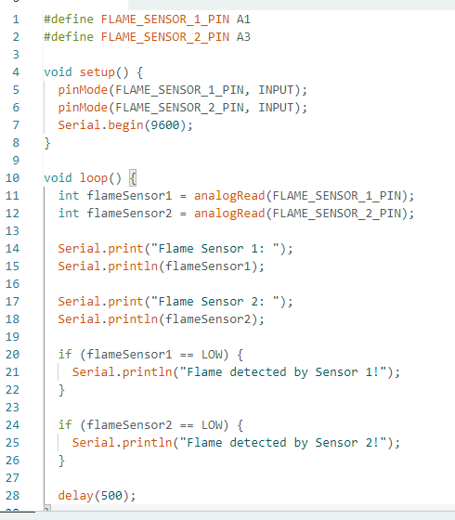

## **5.2.2 MQ2 Gas Sensor (2 Gas Sensors)**

**Pin Configuration**

* GND pin of sensor to GND pin of Arduino
* VCC pin of Sensor to +5 Volts (V) pin of Arduino
* MQ2 Gas Sensors 1and 2 pins to A1and A3 pin of Arduino

The code below reads the analog value from the MQ2 sensor. this sensor is used for check the gas level.

MQ2 Gas Sensors Connect to Arduino Uno Board

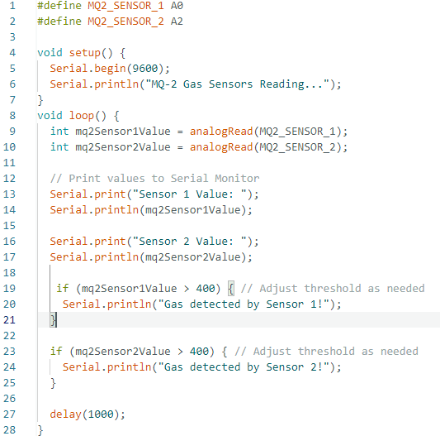

## **5.2.3 12v Buzzer**

**Pin Configuration**

* Buzzer Positive Terminal (long pin) Connect to an Arduino **Digital pin** 4
* Buzzer Negative Terminal (short pin) Connect to the **GND** pin of the Arduino.

Buzzer Connect to Arduino Uno Board.

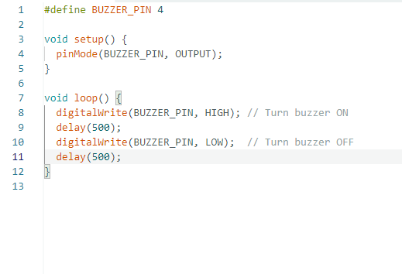

## **5.2.4 Servo Motor**

**Pin Configuration**

* Control Signal (Orange/White): Connect to a digital PWM pin on the Arduino D3
* Power (Red): Connect to a 5V pin on the Arduino.
* Ground (Black/Brown): Connect to the Arduino's GND pin.

To control a servo motor with an Arduino Uno, the Servo library are provided by Arduino. Servo motors are typically used for precise control of angular positions, such as for robotic arms, valve, camera gimbals, or steering mechanisms. here it used to control the gas valve.

Servo Motor Connect to Arduino Uno Board.

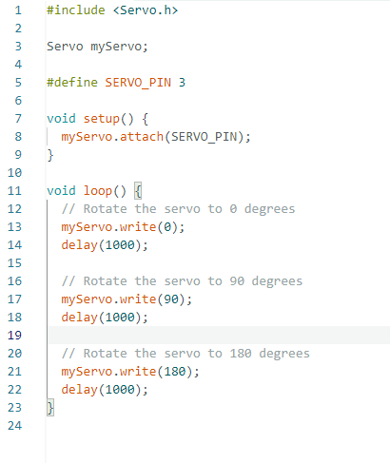

## **5.2.5 SIM900A GSM Module**

Here this is used to notify the user through an SMS and a phone call when a fire or gas leak is detected.

**Pin Configuration**

* SIM900A TXD → Arduino RX (D11)
* SIM900A RXD → Arduino TX (D10)
* SIM900A GND → Arduino GND.
* SIM900A VCC → 5V external power supply (do not power directly from the Arduino for stable operation)

SIM900A GSM Module Connect to Arduino Uno Board.

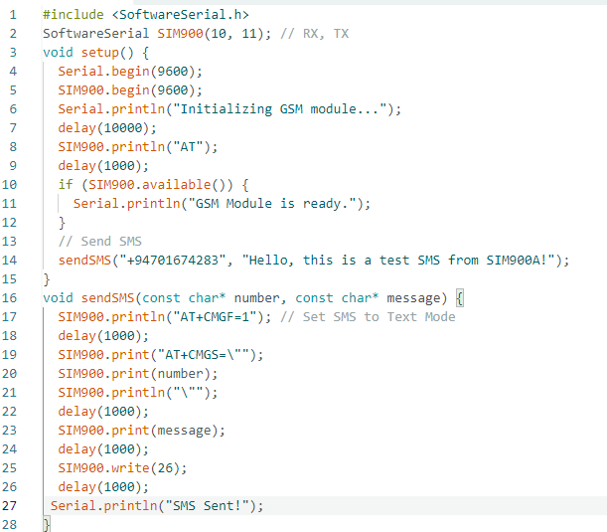

## **5.2.6 MQ2 Gas Sensor Connect to NodeMCU Board (ESP8266)**

Here this is used to send the obtained gas levels to the web site and display them on the LCD display.

**Pin Configuration**

* MQ2 VCC: Connect to the 5V pin of the NodeMCU
* MQ2 GND: Connect to the GND pin of the NodeMCU
* MQ AO (Analog Output): Connect to the A0 pin of the NodeMCU

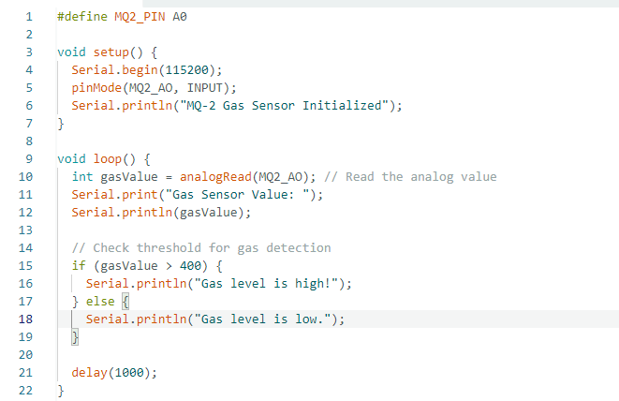

## **5.2.7 DHT11 Sensor Connect to NodeMCU Board (ESP8266)**

To use the DHT11 temperature and humidity sensor with an ESP8266 (like a NodeMCU or ESP-12E), we’ll need the DHT sensor library to easily retrieve readings. The code will read temperature and humidity data from the DHT11 sensor and display it on the Serial Monitor. the temperature and humidity obtained here goes to the web site and the LCD display.

**Pin Configuration**

* DHT11 VCC: Connect to the 3.3V pin of the NodeMCU
* DHT11 GND: Connect to the GND pin of the NodeMCU
* DHT11 DATA: Connect to a digital pin of the NodeMCU D4

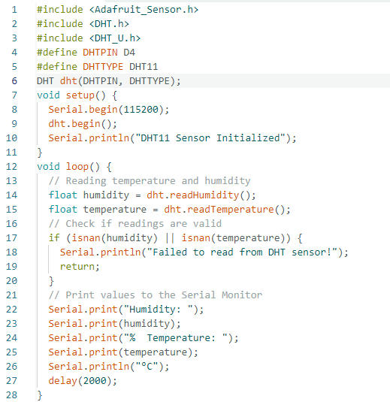

## **5.2.8 Load Cell Sensor Connect to NodeMCU Board (ESP8266)**

Here this is used to detect the gas level in the gas cylinder and then the obtained data is sent to the web site and LCD display.

**Pin Configuration**

* Hx711 VCC: Connect to the 3.3V pin of the NodeMCU
* Hx711 GND: Connect to the GND pin of the NodeMCU
* Hx711 DT: Connect to the D5 pin of the NodeMCU
* Hx711 SCK: Connect to the D6 pin of the NodeMCU

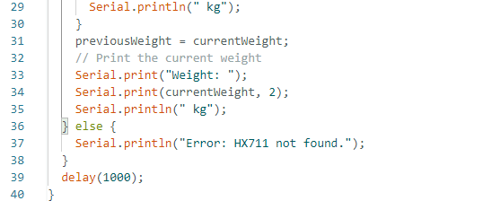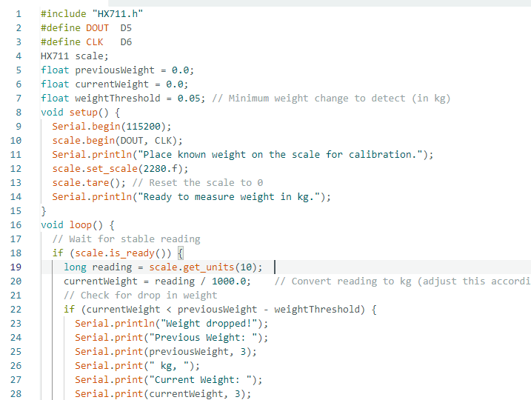

## **5.2.9 LCD Display (16*2) connect to NodeMCU Board (ESP8266)**

To connect a 16x2 LCD display to a NodeMCU (ESP8266), you can use an I2C module or a standard 4-bit parallel interface. Using an I2C module simplifies the wiring considerably. here we use this to respresent the data obtained from the MQ2 gas sensor, temperature sensor and load cell sensor.

**Pin Configuration**

* I2C module VCC: Connect to the 3.3V pin of the NodeMCU or Separate 5v Power Supply
* I2C module GND: Connect to the GND pin of the NodeMCU or Separate Power Supply GND
* I2C module SDA: Connect to the D2 pin of the NodeMCU
* I2C module SCL: Connect to the D1 pin of the NodeMCU

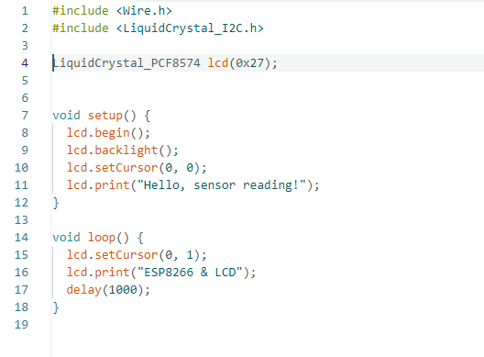

# **5.3 Tools Used**

## **5.3.1 Arduino. IDE**

Arduino IDE is a cross-platform application written in C and C++ with functions. It is used to write and upload programs to Arduino-compatible boards, with the support of third-party cores, and other vendor development boards. Arduino IDE (Integrated Development Environment) is a user-friendly software used for programming Arduino and compatible microcontroller boards. It provides an intuitive interface for writing, compiling, and uploading code, called sketches, saved with a (.ino) file extension. The IDE features a code editor with syntax highlighting and error checking to streamline code creation.

## **5.3.2 Visual Studio**

Visual Studio Code (VS Code) is a versatile, open-source code editor developed by Microsoft, designed for programming across multiple languages ​​and platforms. Available for Windows, macOS, and Linux, VS Code offers a streamlined and customizable interface with essential features such as syntax highlighting, intelligent code completion, and integrated debugging. Key features include a built-in terminal for command-line access, Git integration for version control, and an extension marketplace offering plugins to enhance language support, tools, and themes. VS Code supports remote development and real-time collaboration via Live Share, making it ideal for solo or team projects. This flexibility, combined with extensive multi-language support and customization capabilities, has made VS Code a favorite editor among developers worldwide.

# **5.4 Deployment Architecture**

The deployment architecture of my project entitled "Arduino-based Smart Gas Leak and Fire Detection System with Gas Booking System" outlines the interrelation and organization of the different components that work together to provide the desired functionality. A simplified description is provided as follows:

1. **Central Control Unit:**

* The Arduino Uno microcontroller is the brain of the entire system because it connects with all sensors and components. It processes data coming from the sensors and controls other hardware, such as the buzzer, exhaust fan, and notification system.

1. **Sensors:**

* Gas sensors (MQ2 and MQ5) detect LPG and methane leaks.
* A fire sensor detects any fire hazard.
* A temperature sensor monitors heat levels for additional fire safety.
* A weight sensor measures the level of the gas cylinder to check if a refill is needed.

1. **Alert and Display System:**

* The system uses a buzzer and LED to provide immediate warnings in the event of an accident.
* An LCD display shows real-time air levels, system status, and alerts for easy monitoring.

1. **Communication Modules:**

* A GSM/SIM module sends notifications via SMS or calls to inform users of LPG leaks and fire hazards.
* A Wi-Fi module (ESP8266) connects the system to the Internet, allowing for remote monitoring.

1. **Actuators:**

* A servo motor controls the gas valves, ensuring safety by closing them during leaks and fire.
* An exhaust fan helps remove leaked gas from the area.

1. **IoT Integration:**

* The system sends real-time data to a cloud platform for web site visualization.
* Users can access this data through a web site to monitor the system remotely.

1. **Power Supply:**

* The system is powered by a battery pack or uninterruptible power source to ensure continuous operation.

This architecture ensures that all the elements work together seamlessly sensors monitor hazards, data is processed by the control unit, and the alarm system alerts users while executing automated safety measures. All the more, the integration of IoT and cloud services adds remote accessibility to make the system efficient and user-friendly for residential, commercial, and industrial use.

## **5.4.1 Graphical User Interface**

**5.4.1.1 System Setup**

The system setup for the "Arduino-based Smart Gas Leak and Fire Detection System with Gas Booking System" involves the connection and configuration of various hardware and software components to work correctly. The Arduino Uno is the microcontroller that acts as the brain, to which all sensors and components are connected. The setup provides a complete automated security solution, where real-time monitoring, instant alerts, and remote access are combined for ease of use and improved safety.

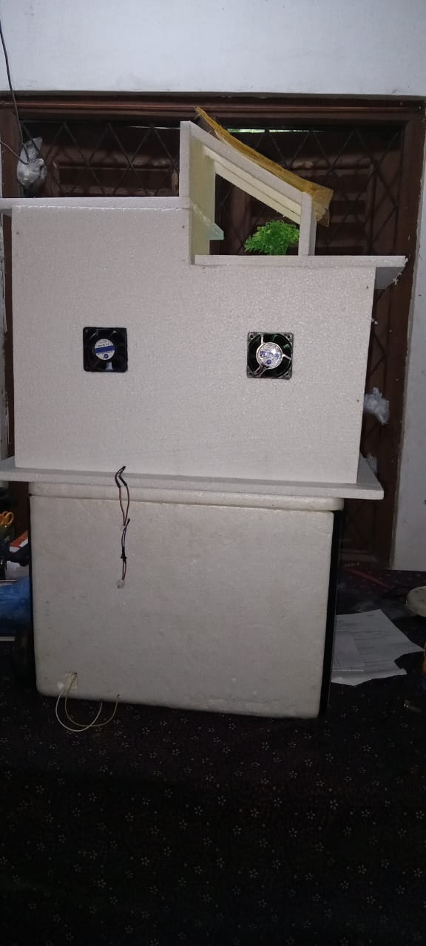

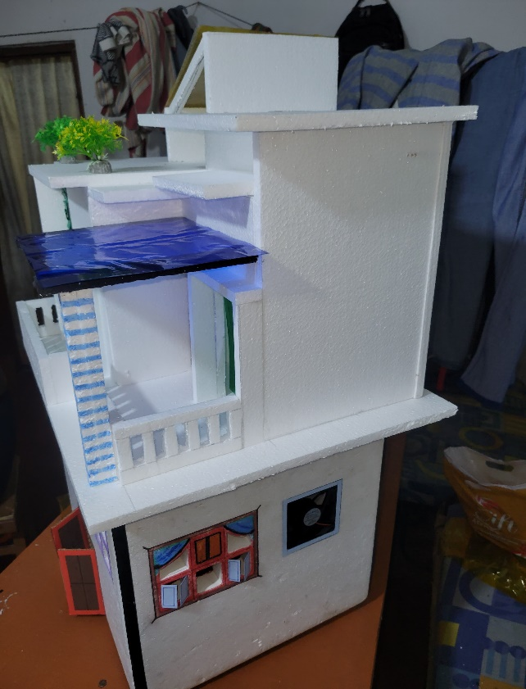

Figure 68 - System Setup

# **5.5 Major Code Segments**

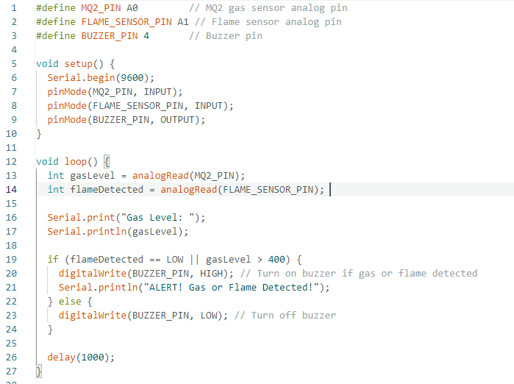**MQ2 Gas Sensor, Flame Sensor and Buzzer Connected to Arduino Uno Board. The Code is Below.**

**MQ2 Gas Sensor, Flame Sensor, Buzzer and Exhaust Fans Connected to Arduino Uno Board. The Code is Below.**

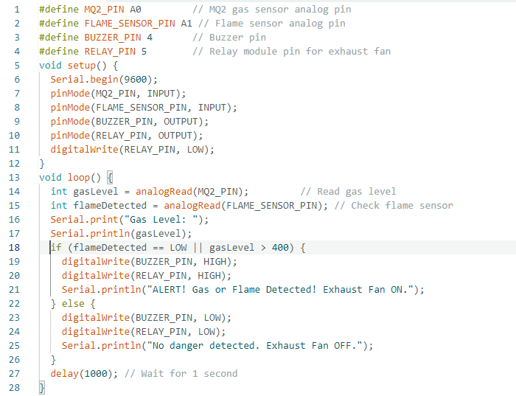

**MQ2 Gas Sensor, Flame Sensor, Buzzer, Exhaust Fans and Servo Motor Connected to Arduino Uno Board. The Code is Below.**

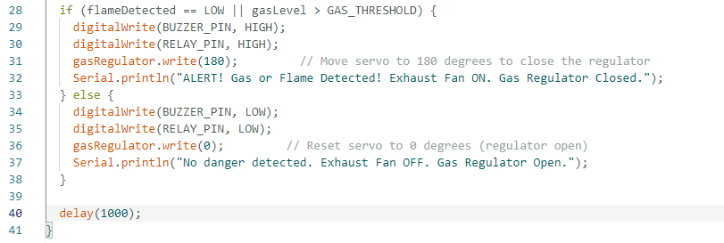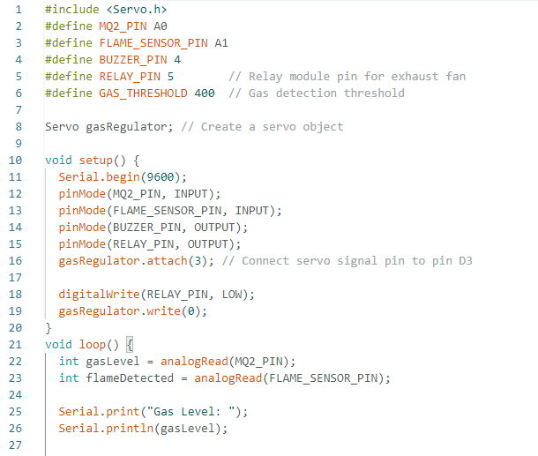

**MQ2 Gas Sensor, Flame Sensor, Buzzer, exhaust fans, Servo Motor and Emergency Lights System Connected to Arduino Uno Board. The Code is Below.**

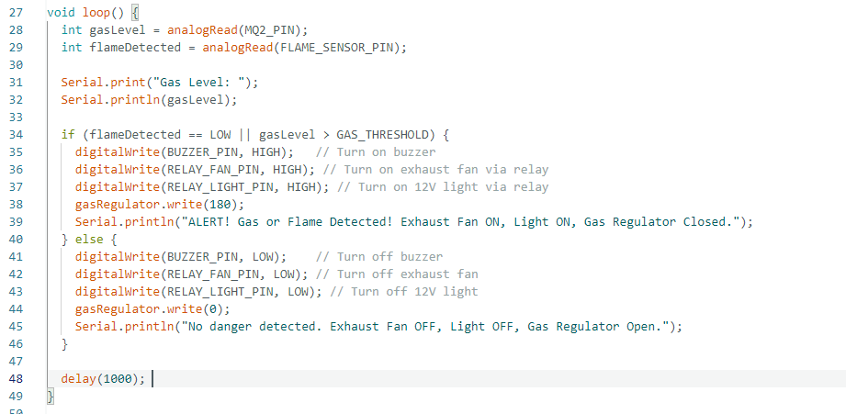

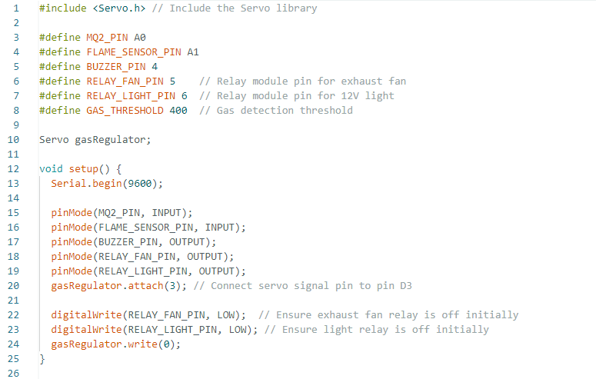

# **Chapter 6 –Testing and Evaluation**

## **6.1 Introduction**

Program testing can be a preparation of the application for execution with the aim of finding errors in computer programs. It is used to check whether the application meets its requirements and whether all the functionalities of the application are implemented. The ultimate goal of testing is to check whether the application runs in the way it is assembled under the specified conditions. All aspects of the code are tested to check the quality of the application. The main reason for testing is to identify computer program failures so that hidden ones can be uncovered and fixed. Test cases are designed in such a way that the scope of finding errors is as extreme as possible.

## **6.2 Testing Procedure**

There is various testing levels based on the specificity of test,

* **Unit testing:** Unit testing refers to tests conducted on a section of code in order to verify the functionality of that piece of code. This is done at the function level.
* **Integration Testing:** Integration testing is any sort of computer program testing that looks to verify the interfacing between components against a program plan. Its primary purpose is to uncover the absconds related to the interfacing of modules.
* **System Testing:** System testing takes, as its input, all of the components that have passed integration testing. The reason of integration testing is to detect any irregularities between the units that are coordinates together. System testing looks for to detect defects both inside the system as an entirety. The real result is the behavior delivered or watched when a component or system is tested.
* **Performance testing:** Performance testing is the process of determining the speed or effectiveness of a computer, network, software program or device such as response time or millions of instructions per second etc.

## **6.3 Test Plan and Test Cases**

A test case is a set of test data, preconditions, expected result and post conditions, developed for a test scenario to verify compliance against a specific requirement. I have designed and executed a few test cases to check if the project meets the functional requirement.

**Test Cases for Fire Sensor**

|  |  |  |  |
| --- | --- | --- | --- |
| **Test No** | **Test Case Description** | **Steps Carried Out** | **Expected Result** |
| 01 | Flame Sensors | Detecting Fire in Case of Fire | Detect the Fire and Send Data to Arduino Uno Board |
| 02 | Fire Alarm | If Detect the Fire, Play Buzzer | Detect the Fire Send the Data to Arduino, and play Buzzer |
| 03 | Emergency Light | If a Fire is Detected, Turn on the Red LED Bulb | Detect the Fire Send the Data to Arduino, and Red Emergency light on |
| 04 | Gas valve | If a Fire is Detected, Close the Gas Regulator | Detect the Fire Send the Data to Arduino, and Close the Gas Regulator |

Table 2 - Test Cases for Fire Sensor

**Test Cases for Gas Sensor**

|  |  |  |  |
| --- | --- | --- | --- |
| **Test No** | **Test Case Description** | **Steps Carried Out** | **Expected Result** |
| 01 | Gas Sensors | Detecting Gas in Case of Gas | Detect the Gas and Send Data to Arduino Uno Board |
| 02 | Fire Alarm | If Detect the LPG Gas, Play Buzzer | Detect the Gas Send the Data to Arduino, and play Buzzer |
| 03 | Emergency Light | If a Gas is Detected, Turn on the Red LED Bulb | Detect the Gas Send the Data to Arduino, and Red Emergency light on |
| 04 | Gas valve | If a Gas is Detected, Close the Gas Regulator | Detect the Gas Send the Data to Arduino, and Close the Gas Regulator |
| 05 | Exhaust Fan | If a Gas is Detected, Start the Exhaust Fans | Detect the Gas Send the Data to Arduino, and Start the Exhaust Fans |

Table 3 - Test Cases for Gas Sensor

**Test Cases for Temperature Sensor**

|  |  |  |  |
| --- | --- | --- | --- |
| **Test No** | **Test Case Description** | **Steps Carried Out** | **Expected Result** |
| 01 | High Temperature | Detecting High Fire Temperature | Detect the High Temperature and Then Display it on the Display and Web Page |
| 02 | Low Temperature | Detecting Low Fire Temperature | Detect the Low Temperature and Then display it on the Display and Web Page |

Table 4 - Test Cases for Temperature Sensor

**Test Cases for Load Cell Sensor**

|  |  |  |  |
| --- | --- | --- | --- |
| **Test No** | **Test Case Description** | **Steps Carried Out** | **Expected Result** |
| 01 | Gas Cylinder Weight | Obtaining the Current Weight of the Gas Cylinder Through the Scale | Representation of the Obtained Weight on the LCD Display and on the Web Page |

Table 5 - Test Cases for Load Cell Sensor

**Test Cases for GSM Module**

|  |  |  |  |
| --- | --- | --- | --- |
| **Test No** | **Test Case Description** | **Steps Carried Out** | **Expected Result** |
| 01 | Receiving a Phone Call and Text Message to the User | Detection of Gas Leakage and Fire | Sending a Phone Call and Text Message About the Fire and Gas Leak to the User |

Table 6 - Test Cases for GSM Module

**Test Cases for LCD Display**

|  |  |  |  |
| --- | --- | --- | --- |
| **Test No** | **Test Case Description** | **Steps Carried Out** | **Expected Result** |
| 01 | Data Show | Simulate Gas Levels, Temperature, Cylinder weight and System Statuses | The LCD Displays Accurate Readings and Status Messages |

Table 7 - Test Cases for LCD Display

**Test Cases for Sensor Data on Web Page**

|  |  |  |  |
| --- | --- | --- | --- |
| **Test No** | **Test Case Description** | **Steps Carried Out** | **Expected Result** |
| 01 | Show Data on Web | Display the Data on Web Page in Quick Time | Run Data and Relay Information on Web Page on Time |

Table 8 - Test Cases for Sensor Data on Web Page

## **6.4 Test Data and Test Results**

**Test Cases for Fire Sensor**

|  |  |  |  |
| --- | --- | --- | --- |
| **Test No** | **Test Case** | **Expected Output** | **Status** |
| 01 | Flame Sensors | Detecting Fire | Pass |
| 02 | Fire Alarm | If Detect the Fire, Play Buzzer | Pass |
| 03 | Emergency Light | If a Fire is Detected, Turn on the Red LED Bulb | Pass |
| 04 | Gas valve | If a Fire is Detected, Close the Gas Regulator | Pass |

Table 9 - Test Cases for Fire Sensor

**Test Cases for Gas Sensor**

|  |  |  |  |
| --- | --- | --- | --- |
| **Test No** | **Test Case** | **Expected Output** | **Status** |
| 01 | Gas Sensors | Detecting LPG Gas | Pass |
| 02 | Fire Alarm | If Detect the LPG Gas, Play Buzzer | Pass |
| 03 | Emergency Light | If a Gas is Detected, Turn on the Red LED Bulb | Pass |
| 04 | Gas valve | If a Gas is Detected, Close the Gas Regulator | Pass |
| 05 | Exhaust Fan | If a Gas is Detected, Start the Exhaust Fans | Pass |

Table 10 - Test Cases for Gas Sensor

**Test Cases for Temperature Sensor**

|  |  |  |  |
| --- | --- | --- | --- |
| **Test No** | **Test Case** | **Expected Output** | **Status** |
| 01 | High Temperature | Detecting High Fire Temperature | Pass |
| 02 | Low Temperature | Detecting Low Fire Temperature | Pass |

Table 11 - Test Cases for Temperature Sensor

**Test Cases for Load Cell Sensor**

|  |  |  |  |
| --- | --- | --- | --- |
| **Test No** | **Test Case** | **Expected Output** | **Status** |
| 01 | Gas Cylinder Weight | Current Weight of the Gas Cylinder Through the Scale | Pass |

Table 12 - Test Cases for Load Cell Sensor

**Test Cases for LCD Display**

|  |  |  |  |
| --- | --- | --- | --- |
| **Test No** | **Test Case** | **Expected Output** | **Status** |
| 01 | Data Show | Simulate Gas Levels, Temperature, Cylinder weight and System Statuses | Pass |

Table 13 - Test Cases for LCD Display

**Test Cases for GSM Module**

|  |  |  |  |
| --- | --- | --- | --- |
| **Test No** | **Test Case** | **Expected Output** | **Status** |
| 01 | Receiving a Phone Call and Text Message to the User | Sending a Phone Call and Text Message About the Fire and Gas Leak to the User | Pass |

Table 14 - Test Cases for GSM Module

# **Chapter 7 - Conclusion and Future Work**

## **7.1 Conclusion**

The "Arduino-Based Smart Gas Leakage and Fire Detector System with Gas Booking System" is a system that efficiently addresses the major safety problems of gas leakage and fire hazards in domestic, commercial, and industrial areas. This is realized through the integration of gas sensors (MQ2 and MQ5), fire sensors, and Internet of Things (IoT) capabilities that give real-time monitoring, quick detection, and fast alerts to the users through SMS, telephonic, and online mode. Other features, including the gas reservation mechanism, exhaust fan activation, and LCD display, add much convenience and safety to the operations. More detailed evaluations have proven its reliability and accuracy in threat detection and response management. This initiative is cost-effective, affordable, and flexible in nature, with a prime focus on enhancing the measure of safety and lessening the chances of accidents from gas leakage and fire.

## **7.2 Future Work**